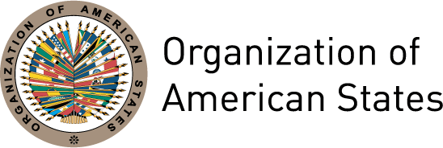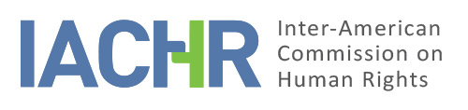

OAS/Ser.L/V/II.152
Doc. 21
14 August 2014
Original: Spanish

INTER-AMERICAN COMMISSION ON HUMAN RIGHTS

Considerations Related to the Universal Ratification of the American Convention and other Inter-American Human
Rights Treaties

2014
www.iachr.org

OAS Cataloging-in-Publication Data

Inter-American Commission on Human Rights.
Considerations related to the universal ratification of the American Convention and other Inter-American Human Rights Treaties.

v. ; cm. (OAS. Official records; OEA/Ser.L)
ISBN 978-0-8270-6358-7

1. Human rights--America. 2. Civil rights--America. I. Title. II. Series: OAS. Official records ; OEA/Ser.L.
OEA/Ser.L/V/II.152 Doc.21

INTER-AMERICAN COMMISSION ON HUMAN RIGHTS

Members

Tracy Robinson

Rose-Marie Belle Antoine

Felipe González

José de Jesús Orozco Henríquez

Rosa María Ortiz

Paulo Vannuchi

James L. Cavallaro

Executive Secretary

Emilio Álvarez-Icaza L.

Assistant Executive Secretary

Elizabeth Abi-Mershed

Approved by the Inter-American Commission on Human Rights on August 14, 2014

TABLE OF CONTENTS

CHAPTER 1 | INTRODUCTION 9

A. Principles related to universality 11

B. Developments towards universality within the inter-American
human rights system 15

CHAPTER 2 | CHALLENGES IN THE PATH TO UNIVERSALITY
IN THE INTER-AMERICAN HUMAN RIGHTS
SYSTEM: PENDING ISSUES 19

A. Obstacles to the efficacy of the inter-American system 19

B. Obstacles to access to justice and to the inter-American system
as a second recourse for protection 23

C. Challenges to incorporating inter-American standards at the national level 25

CHAPTER 3 | CONTRIBUTIONS OF UNIVERSALITY: EXAMPLES 37

CHAPTER 4 | CONCLUSIONS, RECOMMENDATIONS,
AND FUTURE STEPS 47

ANNEX | Status of ratification of inter-American instruments 49

CHAPTER 1
INTRODUCTION

INTRODUCTION

      - The Inter-American Commission on Human Rights (hereinafter “the Inter-American Commission,” “the Commission,” or “the IACHR”) has on several occasions emphasized the importance of universal acceptance of the instruments of the inter-American system as a critical ingredient to ensure full respect for and the guarantee of human rights in the Americas. In various forums, the IACHR has reiterated the pressing need for the OAS Member States to employ all the methods available to them to overcome impediments to the ratification and full implementation of all the inter-American instruments.

      - Consistent with these principles, the IACHR included as a priority objective in its Strategic Plan for 2011-2015 “promoting the observance of human rights, knowledge and understanding of the system, and universal acceptance of the regional human rights instruments.” This goal is pursued by the IACHR with the understanding that the current system of varying degrees of ratification “leaves millions of people at a disadvantage in terms of the degree of international protection of their rights.” In addition, the IACHR has emphasized that it is important for the OAS Member States to ratify not only the American Convention but all inter-American human rights protection instruments as well. The OAS Member States have also highlighted on various occasions the priority of universal acceptance of the inter-American system of human rights and have urged those States that have not done so to sign, ratify, or accede to all inter-American human rights instruments as soon as possible.

      - In that context, the IACHR was engaged in an important process of reform between 2011 and 2013, during which it closely examined its procedures, policies, and practices. Within this characteristically participatory process, the IACHR received a variety of inputs from state and non-state actors indicating that the full effectiveness of the inter-American system requires the member States to ratify all inter-American human rights treaties. The IACHR has prepared this report as part of the commitments undertaken during this process of reform.

      - With these considerations in mind, this report has been prepared to accomplish a number of objectives. First, the report seeks to encourage universal ratification of all inter-American instruments, as a necessary step toward full protection of human rights within the region. To that end, the report discusses a number of concerns and the progress made toward universal acceptance of human rights treaties within the Americas. The idea is to induce the OAS member states to reflect upon the obstacles that stand in the way of universal acceptance. Second, the report endeavors to cultivate a general respect for human rights within the Americas by encouraging not just universal ratification of the inter-American human rights instruments but also compliance with their provisions. The legal development of standards within the inter-American system must be matched by the States’ efforts to put those standards into practice. Third, another of the report’s intended objectives is to communicate an understanding of the content of the inter-American instruments for the protection of human rights. A fourth priority is to assist the OAS member states in fulfilling their human rights obligations.

      - Application of the standards of the inter-American human rights system throughout the Americas has been and is an uneven, slow-moving process requiring specific, deliberate, and immediate efforts on the part of the States to close the gap between the principles upheld in the inter-American instruments and their implementation in practice. Full ratification of all inter-American human rights treaties is an effort that must be undertaken to achieve the best protection possible of the human rights of all persons.

A. Principles related to universality

      - Before examining the challenges and progress thus far achieved in the ratification of inter-American human rights instruments, it is important to note that this report works from a set of premises that underlie the goal of universal ratification of inter-American instruments.

      - First, it bears repeating that all human rights are universal, indivisible and interdependent and interrelated. This implies, on the one hand, that the protection of civil and political rights is closely linked to the protection of economic, social, and cultural rights. On the other hand, it creates an obligation incumbent upon States, which is to devote particular attention to those social sectors and individuals that have historically suffered forms of exclusion or have been victims of presistent prejudice. States must also take immediate steps to prevent, reduce, and eliminate the conditions and attitudes that either generate or perpetuate discrimination in practice. These principles are embodied in the instruments that govern the workings of the inter-American human rights system. Because the latter is an integral system, it is imperative that the American Convention and all other inter-American human rights treaties be ratified in order to afford the people of the Americas the best possible protection. This is reinforced by the necessary nexus between the protections provided under the inter-American system and those provided by the universal system of human rights.

      - Second, the IACHR emphasizes that full observance of human rights is important for achieving solid and inclusive democracies. The ratification of international treaties protecting human rights is an indicator of the quality of a country’s democracy, facilitating the integration of its citizens’ voices and demands in all spheres of public policy. In turn, the ratification of international instruments promotes respect and guarantee for the obligation not to discriminate and for the principle of equality – the framing principles of the international system for the protection of human rights and essential for ensuring coherent, representative, and sustainable democracies. It is worth noting that when they created the Inter-American Commission the States recognized that “harmony among the American Republics can only be effective insofar as human rights and fundamental freedoms and the exercise of representative democracy are a reality within each one of them…” Even in countries with great democratic conditions, stable institutions, and a developed system of human rights standards and regulations, the international and inter-American system of protection constitutes a supplemental level of protection for citizens, an aspect that is particularly important for members of groups and communities historically subject to discrimination in their countries as in the case of indigenous peoples and communities of African descent, among others.

      - Third, the IACHR would also point to how ratification of international instruments for the protection of human rights is compatible with State sovereignty. Respect for the sovereignty of the States is an important premise of the universality principle and the process of voluntarily undertaking human rights obligations. Since its establishment, one of the clear objectives of the OAS has been the protection of human rights, consistent with its defense of the sovereignty of States, upheld in Article 1 of the OAS Charter. Ratification of international instruments advances the goals of hemispheric integration established in the OAS Charter and other instruments that the American States have agreed to.

      - Fourth, the ratification of inter-American instruments sends a public message regarding the priority attached to the protection of human rights. It also opens a door to international protection when the national system fails to offer a remedy. This principle has important repercussions for the justice system, as the administration of justice is the first line of defense in the protection of human rights at the domestic level. A critical nexus exists between a solid democracy and the strength of its judicial branch, particularly with respect to the protection of groups, communities and sectors that are especially at risk of violation of their human rights, and persons beset by poverty and exclusion.

      - Fifth, ratification of inter-American human rights instruments must be followed by implementation of their provisions at the national level. International instruments in general require that the States Parties not only respect the rights recognized therein, but that they also guarantee the exercise of those rights to all persons subject to their jurisdiction. States have an obligation to act with the due diligence necessary to prevent, investigate, and punish any violation of human rights and to fully redress such violations when they occur. They must organize the structure of the State so that it is capable of properly responding to human rights violations, including conduct by their own institutions, branches of government, programs and services; then, too, they must create the conditions necessary to enable full exercise of human rights.

      - The obligation to act with due diligence also entails the adoption of a legal framework reflecting international and inter-American standards for the protection of human rights; the existence of a system for the administration of justice that is independent, impartial and has sufficient human and financial resources; the use of reasonable measures to protect activities in defense of human rights; the existence of suitable and effective remedies for reporting those human rights violations that occur; and the granting of comprehensive reparations when human rights violations occur, among other measures. The adoption of reforms and reparations intended to be transformative is in turn necessary in cases of structural discrimination. Ratification of inter-American instruments must be matched by the political resolve of the States to earmark the human and financial resources necessary to ensure proper fulfillment of their obligations and a strong civil society that demands that those obligations be fulfilled.

      - Sixth, the non-ratification of inter-American instruments has repercussions of varying dimensions for the OAS Member States and those who live in those States. First, it may represent a significant constraint on the full exercise of citizenship and the development of standards, public policies, and measures intended to protect and ensure everyone’s enjoyment of rights, essential elements for an inclusive democracy. It maintains the door shut to a protection system of a complementary nature which may be vital for persons in a specific situation of vulnerability and thus subject to violations of their human rights, such as those affected by poverty and historical situations of discrimination. Second, it limits the effectiveness of discourse on human rights as expressed by those States that have not ratified, as well as their regional and international leadership on these subjects. Third, it constitutes an obstacle to OAS regional integration goals and to sustainable opportunities for multilateral cooperation in the Americas and at the international level.

      - It is also important to reiterate in this report that the scope of the IACHR’s jurisdiction extends to the entire region and in that sense it may analyze and review petitions related to States that have not ratified the American Convention on Human Rights and other inter-American instruments. The American Declaration is a source of international obligations for all the OAS Member States..

      - The American Declaration is part of the human rights framework established by the OAS Member States, referring to the obligations and responsibilities of the States, and requires that they refrain from supporting, tolerating, or participating in acts or omissions that contravene their commitments in the area of human rights. As the Declaration is a source of legal obligations, the States must implement in practice, within their jurisdictions, the rights established in that Declaration.

      - However, as the inter-American human rights system has repeatedly pointed out, universal ratification of the inter-American human rights instruments is essential to achieving full protection of the human rights of all persons within the Hemisphere.

B. Developments towards universality within the inter-American human rights system

      - Inasmuch as the inter-American human rights system is integral in nature and its instruments mutually reinforcing, at the present time four levels of participation in the inter-American system can be discerned among the OAS member states:

- First, a universal, minimum level of protection exists with respect to all 35 OAS member states, whose inhabitants enjoy IACHR-supervised protection of the rights recognized in the American Declaration and the OAS Charter.

- Second, a group of 23 member states has ratified the American Convention and continue being State parties to said instrument.

- Third, a group of 20 member states has accepted the jurisdiction of the Inter-American Court and their acceptance is still in force.

- Fourth, a group of 7 member states has ratified all the inter-American human rights treaties.

      - The IACHR has repeatedly observed that this arrangement has left millions of people at a disadvantage in terms of the degree of international protection of their rights. After forty-five years since the adoption of the American Convention in November 1969, 12 of the 35 OAS member states have not yet ratified it, and 15 have yet to accept the contentious jurisdiction of the Inter-American Court of Human Rights. At the same time, only seven OAS member states have ratified all the inter-American instruments for the protection of human rights.

      - The IACHR has publicly lamented the fact that two OAS member states have denounced the American Convention: Trinidad and Tobago (May 1999) and Venezuela (September 2013). The Commission has also highlighted that the citizens of Trinidad and Tobago and Venezuela have been deprived of an important avenue for the protection of their human rights. The Commission reiterates its profound concern over the effect of these denunciations and calls these States to reconsider their decision.

      - The Commission also undescores the fact that these denunciations from Trinidad and Tobago and Venezuela in no way prevent the organs of the inter-American human rights system from continuing to take cognizance of petitions alleging violations of the American Convention for acts that occurred before the two states denounced the Convention, and that the Commission has competence under the American Declaration.

      - It is only fitting, however, that this report should also celebrate the recent progress that has been made with the ratification of inter-American instruments. It recognizes the efforts in the past ten years of States such as Argentina, Bolivia, Brasil, Chile, Colombia, Ecuador, Haiti, Honduras, Jamaica, Mexico, Nicaragua, the Dominican Republic and Venezuela to ratify various inter-American human rights treaties.

CHAPTER 2
CHALLENGES IN THE PATH TO UNIVERSALITY IN THE
INTER-AMERICAN HUMAN RIGHTS SYSTEM: PENDING ISSUES

CHALLENGES IN THE PATH TO UNIVERSALITY IN THE INTER-AMERICAN HUMAN RIGHTS SYSTEM: PENDING ISSUES

      - This section examines a number of concerns and considerations about the effects that the non-ratification of the American Convention and other inter-American instruments has in three basic areas. First, it analyzes the impact that the limited participation of countries like the United States, Canada, and the Caribbean countries has had on the activities and efficacy of the inter-American human rights system. Second, it underscores how the non-ratification of inter-American instruments compounds the obstacles to access justice that millions of people within the Americas encounter when their human rights are violated. Lastly, it examines at how non-ratification can become a factor that deters the development of laws, public policies, and programs consonant with international principles of human rights and the standards of the inter-American system, which also poses a major obstacle to the development of State institutions entrusted with the advancement of human rights.

A. Obstacles to the efficacy of the inter-American system

      - Historically, the Commission has pursued the objective of increasing the effectiveness of its protection and promotion functions, as well as supporting the OAS Member States in strengthening their own internal capacities and perfecting their mechanisms for protecting human rights. It has also indicated that ratification by the States of all inter-American human rights treaties is fundamental to full achievement of this objective.

      - Civil society in the hemisphere has also recognized the nexus between the efficacy of the inter-American system and the States’ ratification of all inter-American instruments. On this point, various civil society organizations reported in response to the questionnaire circulated by the IACHR on this subject that ratification of the inter-American instruments in their respective countries has facilitated their participation in IACHR thematic hearings, visits, and reports and their ability to submit petitions and cases to the bodies of the inter-American system. This has allowed victims, organizations, movements, and human rights defenders valuable opportunities to shine a light on standards, policies, and practices that are in violation of human rights. It has also provided important tools for promoting legislative reforms and has led to training sessions for judicial authorities to promote application of the inter-American standards.

      - In this section, the IACHR reviews some considerations regarding how non-ratification of all inter-American instruments impacts the effectiveness of the inter-American system.

      - First, the IACHR notes with concern the relatively low number of petitions in individual cases submitted in reference to countries where the American Convention has not been ratified, as compared to cases submitted from countries where that document has been ratified. This has been reflected in a lower number of individual cases decided by the IACHR in reference to those countries and thus a limited number of standards on various subjects. The IACHR has received ample information from different sectors on how the decisions of the IACHR in its reports on cases can have a reparatory effect for the victims involved, set important standards on priority human rights themes in the region, and serve as an important guide for the States in the design of their legislation, policies, and practices.

      - This concern is particularly important as regards groups, sectors, and communities that have historically been subject to discrimination or situations of exclusion based on risk factors such as their sex, gender, race, ethnicity, economic positions, and other traits. The inter-American system has been used as an important forum for developing jurisprudence benefiting sectors and communities that have endured historical discrimination such as women and indigenous peoples, but has had limited capacity to set relevant standards in this area in countries where not all the inter-American instruments have been ratified. The failure to ratify all the inter-American instruments also keeps the door shut for victims of human rights violations with ESCR, gender, discrimination, intolerance, and disability components – subjects that enjoy special protection in the specialized treaties. The same can be said of the victims of human rights violations such as torture, the death penalty, and forced disappearance.

      - Along the same lines, there are fewer requests for precautionary measures from the above-mentioned countries. The IACHR has emphasized that this mechanism has been able to prevent irreparable harm to thousands of people in at-risk situations in the hemisphere and represents one of the major tools of the IASHR for preventing serious human rights violations.

      - Second, and consistent with the first point, there are also fewer requests for hearings before the IACHR on cases and priority themes in these countries. This reflects under-utilization by victims and the organizations that represent them in discussions with the IACHR, where they can present their concerns and complaints with respect to various subjects. Another result is that the IACHR sometimes has more limited information on priority human rights problems affecting countries that have not ratified the American Convention and other inter-American instruments.

      - Third, the IACHR notes with concern that the large majority of invitations it has received to conduct on-site and working visits to countries in the Americas has come from countries that have ratified the American Convention, resulting in a limited number of visits to countries that have not ratified that instrument. This means that the IACHR’s ability to issue recommendations relevant to legislation and policies, to monitor general human rights compliance, to provide technical assistance to the States, and generally to have a presence has been extremely limited in countries where the American Convention and other inter-American instruments have not been ratified.

      - Fourth, the above considerations indicate that the conditions for inter-American system activity continue to be more favorable in those Latin American countries that are States Parties to the American Convention. The limited participation in the inter-American system of countries like the United States and Canada curbs opportunities for north-south sharing of experiences in the Americas on progress made, challenges, and good practices in human rights protection. The IACHR has emphasized that the ratification of inter-American instruments furthers the integration goals of the OAS and ensures that all citizens of the Americas enjoy the full protection of their rights.

      - Despite the concerns indicated above, it is also important for the IACHR to recognize the extent to which the United States, Canada, and the Caribbean countries that have not ratified the American Convention participate in the implementation of various mechanisms of the inter-American system. For example, various Commissioners and Judges of the Inter-American Court have come from those countries, and those States have participated in thematic hearings before the IACHR on important human rights topics. Several States have in turn created conditions conducive to the organization of promotional and training activities regarding the inter-American standards. The States have also offered the Commission the opportunity to undertake working visits related to priority human rights issues.
      - Ratification would offer these countries the opportunity to play a more active role in the implementation of the mechanisms of the inter-American system and would increase their leadership and the credibility of their interventions in the area of human rights in the Americas.

B. Obstacles to access to justice and to the inter-American system as a second recourse for protection

      - The efficacy of the inter-American system is linked to its activity as a second recourse to which persons can turn when they have difficulty accessing the domestic justice system for protection of their human rights. The IACHR has consistently singled out access to justice as one of the main challenges for genuine observance of human rights in the Americas. This matter is of particular concern in the case of those sectors that have historically been victims of discrimination, and is apparent from the many petitions that the Commission receives each year.

      - Hence, it is vital that the inter-American system is able to function as a subsidiary source of redress and protection for persons whose human rights have been violated. Thus, the previously discussed challenges to the efficacy of the inter-American system have repercussions for access to justice in the case of individuals whose human rights have been violated in countries that have not ratified the American Convention. On this subject in particular, the IACHR has in the past observed that:

…the inter-American system must be a subsidiary source of redress and protection for victims. The cases before the regional system point up the considerable challenges and inadequacies at the national level and make their solution a priority. The concept of access to justice recognizes, however, that the existence of institutions does not suffice to ensure vindication of violated rights. There must be material access as well (the proximity of institutions, for example) or, failing that, efficient and swift mechanisms to ensure that channels of communication are in place to enable information to flow between the person in question and the operators of justice. There must also be guarantees that the proceedings will be accessible (i.e., that they will be simple or, when they have to be complex because of the nature of subject matter, that the State will provide the services of an attorney to those who require such services). Then, too, when the justice system issues its decisions on a matter, that decision has to be enforced. All these are integral parts of access to justice, broadly defined. Because of the existing obstacles, the victims’ access to an effective subsidiary recourse is not what it should be. The IASHR must be strengthened so that all victims of human rights violations who cannot find justice in the domestic system are able to turn to the Commission as a subsidiary resource to have their rights properly addressed.

      - The refusal to accept the jurisdiction of the Inter-American Court only serves to exacerbate the barriers to access to justice that millions of people in the Hemisphere encounter. Between 1987 and the present, the IACHR has brought close to 200 contentious cases to the Inter-American Court of Human Rights, resulting in judgments covering a variety of human rights priorities in the Americas. The orders issued by the Inter-American Court of Human Rights have set universally recognized standards on the scope of reparations, the protection of human rights during periods of repression, political violence and armed conflict, the problem of impunity for human rights violations, access to justice by individuals, groups, and communities that have historically been the targets of discrimination, obstacles standing in the way of the consolidation of democracies in the Hemisphere, and other matters.

      - Non-acceptance of the Inter-American Court’s jurisdiction has also constrained the evolution of the Inter-American Court’s case law in two respects. On the one hand, the Court has not had an opportunity to decide contentious cases involving one third of the OAS member states. This has meant that these States and the affected parties cannot benefit from the jurisprudence of the Court as a body authorized to interpret the American Convention, the American Declaration and other inter-American treaties. On the other hand, the Court has been constrained from establishing standards in individual cases that happen in English-speaking countries governed by the common law system and where human rights violations occur in a sociopolitical and cultural context different from that of the Latin American countries.

C. Challenges to incorporating inter-American standards at the national level

      - Non-ratification of inter-American instruments can likewise be an obstacle to incorporating inter-American standards into the legislation, policies, and practices of States. The IACHR has expressed its concern on a number of occasions about the gap between the commitments made by the States in inter-American human rights instruments and the pressing human rights situation confronting millions of people in the Hemisphere. While considerable headway has been made in implementing IACHR recommendations and in complying with the Court’s decisions, a level of compliance has not yet been reached that would ensure effectiveness of the inter-American system.

      - In this context, the failure to incorporate inter-American standards at the national level is a matter of priority in countries that have not ratified the inter-American human rights instruments. The Commission considers that this is illustrated by several examples.

      - An important case in point is the low level of compliance with the decisions adopted by the IACHR under the American Declaration. In its annual report for 2013, the IACHR presented information on the status of compliance with the IACHR recommendations issued in the 219 cases settled and published over the previous 11 years. It should be pointed out that 27 of those cases involved countries that had not ratified the American Convention, 19 of which resulted in decisions that are yet to be complied with. There was full compliance in only one of the 27 cases.

      - The IACHR has also referred to serious situations of human rights violations in various countries that have not ratified the American Convention in its reports on individual cases, country reports, thematic reports, and precautionary measures. In turn, it has convened a significant number of hearings on those countries, alluding to priority themes relevant to the exercise of civil, political, economic, social, and cultural rights.

      - The IACHR received responses from non-state actors to its questionnaire on universality, with examples of pending priority challenges in terms of the incorporation of human rights in the legislation and policies of countries that have not ratified the American Convention and other inter-American instruments. Non-ratification can contribute to a situation of ignorance and under-utilization of the bodies of the inter-American system and its legal precedents and recommendations on the part of State institutions, public officials, and society in general. However, it is important to recognize some important local efforts in the adoption of resolutions furthering human rights in countries that have not ratified the American Convention, sometimes as a result of decisions made by the IACHR under the American Declaration. In addition, the States have reported in other international procedures significant efforts in the adoption of legislation, policies, programs, and interventions designed to protect human rights.

      - The IACHR also emphasizes different types of information it received in questionnaire responses alluding to how ratification of inter-American instruments has facilitated the incorporation of precepts contained in the inter-American instruments in the legislation, policies, decrees, and resolutions of various American states. For example, the State of Guatemala reported that the system’s standards “have helped to established criteria for the oversight, control, and participation of various sectors of society, for the purpose of subsequent supervision of policies, plans, programs, projects, pacts, and strategies, through citizen participation and the exercise of social audit that makes it possible to obtain greater legitimacy and social and political consensus both domestically and institutionally.” The State of Argentina emphasized domestic laws that arose from the context of cases or friendly settlements the text of which incorporated the standards of the inter-American system, such as amendment of the penal code with respect to the crime of defamation and libel as the result of the Inter-American Court’s judgment in the Kimel v. Argentina case.

      - Various States reported how the standards of the inter-American system have guided their policies on sectors particularly exposed to human rights violations such as women, children, and indigenous peoples. Other States such as Costa Rica, Guatemala, and Colombia emphasized the establishment of institutions at the national level to promote effective compliance with the decisions of both the IACHR and the Court.

      - In their responses to the questionnaire, a group of non-state actors included examples of good practices in the incorporation of the system’s standards, to be discussed in greater depth below, such as Mexico’s 2011 constitutional reform raising human rights treaties to constitutional rank; the elevation since 1994 of certain human rights treaties like the American Convention to constitutional rank in Argentina; the adoption of the Maria da Penha Law on domestic violence in Brazil; enactment of the Law on Transparency and Access to Public Information by the Colombian Congress in June 2012, later endorsed by the Constitutional Court in May 2013; and adoption of the Jamaican Charter of Fundamental Rights and Freedoms (Constitutional Amendment) Act 2011; among other measures.

      - As for judicial branch activity, various countries reported to the IACHR on the development and implementation of the concept of conventionality control to ensure that judges review the compliance of domestic measures with international commitments in the area of human rights, and provided examples reflecting this phenomenon. Guidelines and training programs have also been developed and implemented, reflecting the content of the inter-American system’s standards in countries like Colombia, Guatemala, and Uruguay. The IACHR has also emphasized in its earlier reports examples of judicial decisions adopted by judicial branch bodies that refer to standards of the inter-American system such as the American Convention and the Convention of Belém do Pará and examples were provided in different responses to the questionnaires.

      - These data show that ratifying the inter-American instruments may contribute to the legal framework of human rights at the national level and foster the development of a culture in keeping with human rights. They may also provide greater tools with which a State can increase its public officials’ knowledge of their human rights obligations, raise understanding of human rights as a framework for action, and promote greater inclusion of human rights in public discourse.

      - The IACHR also urges various countries to find strategies to overcome historical positions that have been an impediment to the ratification of inter-American instruments and full compliance with their human rights obligations.

      - For example, despite the U.S. government’s broad support for the work of the IACHR and the inter-American human rights system, the United States has consistently maintained before the IACHR that the American Declaration and its recommendations issued under this instrument are not binding. The U.S. government has asserted the following on the legal status of the American Declaration before the inter-American system:

The American Declaration of the Rights and Duties of Man represents a noble statement of the human rights aspirations of the American States.

Unlike the American Convention, however, it was not drafted as a legal instrument and lacks the precision necessary to resolve complex legal questions. Its normative value lies as a declaration of basic moral principles and broad political commitments and as a basis to review the general human rights performance of member states, not as a binding set of obligations.

The United States recognizes the good intentions of those who would transform the American Declaration from a statement of principles into a binding legal instrument. But good intentions do not make law. It would seriously undermine the process of international lawmaking – by which sovereign states voluntarily undertake specific legal obligations – to impose legal obligations on states through a process of “reinterpretation” or “inference” from a non-binding statement of principles.

      - The government of the United States has also manifested before the Inter-American Commission that the American Declaration is “a non-binding instrument that does not itself create legal rights or impose legal obligations on signatury states” and that it does not constitute a source of affirmative obligations such as the exercise of due diligence. In response to these arguments, the Commission reiterates that the American Declaration constitutes a source of legal obligations for all OAS Member States, including those who have not ratified the American Convention, as part of the system, the OAS Charter, and also the IACHR Statute. In its jurisprudence, the Commission has established that:

.....The American Declaration is recognized as constituting a source of legal obligation for OAS member states, including those States that are not parties to the American Convention on Human Rights. These obligations are considered to flow from the human rights obligations of Member States under the OAS Charter. Member States have agreed that the content of the general principles of the OAS Charter is contained in and defined by the American Declaration, as well as the customary legal status of the rights protected under many of the Declaration’s core provisions.

The inter-American system has moreover held that the Declaration is a source of international obligation for all OAS member states, including those that have ratified the American Convention. The American Declaration is part of the human rights framework established by the OAS member states, one that refers to the obligations and responsibilities of States and mandates them to refrain from supporting, tolerating or acquiescing in acts or omissions that contravene their human rights commitments.

      - It has also observed that it considers its legislation to be more advanced in certain areas than the provisions contained in instruments such as the American Convention. Various academics have written extensively on concerns derived from federalism, the possible interference of international matters and domestic matters, and consistent interpretation between the provisions of the American Convention and the domestic legislation of the United States.

      - With respect to Canada, the IACHR has received information regarding concerns about the alleged incompatibility between Canadian law and the provisions of the American Convention. This subject was explored by the Canadian Senate’s Committee on Human Rights, which published a report in May 2003 concluding that there are no compelling reasons for Canada not to ratify the American Convention. In preparing this report, the Committee received information from state and non-state actors regarding conflicts between Canadian law and the following dispositions of the American Convention: the scope of the right to life under Article 4(1); the right to freedom of expression under Article 13; the right to indigenous property under Article 21; and the right to equality under Article 24, among other provisions of the same instrument. Other obstacles discussed to the ratification of the American Convention were limited potential impact given Canada’s extensive legal framework protecting human rights and the need for reservations should the Convention be ratified. Nonetheless, the Committee considered those obstacles surmountable.

      - The Committee also identified a series of advantages if the American Convention were ratified by Canada, including, strengthening of the inter-American system of human rights and Canada’s leadership and credibility within that context; the ability to nominate more candidates to positions with the IACHR and the Court; increased human rights protection for Canadians; and encouragement for other States with a common law legal system such as the United States to ratify the American Convention. The IACHR for its part has recommended Canada’s accession to the American Convention and other inter-American instruments.

      - For its part, CARICOM has publicly demonstrated that certain factors affect the low level of ratification of the American Convention among the English-speaking Caribbean states. Several CARICOM member states, having entered the OAS recently, perceive the areas of emphasis of the IACHR as being different from those of the CARICOM. There is widespread ignorance of the inter-American system in this region. Both the IACHR and the Court should have more representation in those countries, and these countries do not have the resources necessary to participate properly in the activities of both bodies. Historically, the IACHR has received information on concerns regarding the imposition of the death penalty and the standards governing the protection of LGBTI communities.

      - However, it is important for the IACHR to emphasize that all the English-speaking countries in the Caribbean have ratified the Convention of Belém do Pará and have adopted legislation on violence against women, which evidences the region’s potential for achieving more substantial participation in the inter-American human rights system. The Commission also takes advantage of the opportunity to highlight that the American Convention is consistent with the obligations already contracted by Caribbean States under the American Declaration and those contained in the universal treaties they have ratified. The principles reflected in the American Convention are also consonant with various dispositions in the national constitutions of Caribbean states. The ratification of the American Convention would also offer Caribbean States the opportunity to have a more influential and visible role in the sphere of human rights in the Americas in general.

      - As it has in the past, the IACHR reiterates its willingness to engage in dialogue with countries regarding the various obstacles they face for ratifying the inter-American instruments, with a view to overcoming them. Even in countries with highly democratic institutions and solid human rights regulatory frameworks, State agencies have reiterated that ratification of international and inter-American treaties and recognition of the Court’s jurisdiction may offer individuals another level of protection not provided by their domestic courts. It also gives States the opportunity to examine the impact in practice of their legislation, policies, and practices, so as to improve their response to situations where human rights are violated, and to inform their citizens and the international community of their efforts.

CHAPTER 3
CONTRIBUTIONS OF UNIVERSALITY: EXAMPLES

CONTRIBUTIONS OF UNIVERSALITY: EXAMPLES

      - In this section the IACHR identifies three crucial moments when universality and the ratification of inter-American instruments has made significant contributions to the process of creating conditions more favorable to the protection of human rights in the Americas. The IACHR believes that these contributions were illustrated during: i) the transition from dictatorships and repressive regimes to democracy in Latin American countries; ii) during the consolidation of democracy and an inclusive rule of law; and iii) in the current process of strengthening democratic institutionality. At these three points, a tangible influence is seen of the inter-American instruments in the design of constitutions, laws, and public policies; in the creation of institutions consistent with international human rights standards; and in the adoption of court decisions facilitating respect for the international human rights framework. In addition, civil society and other sectors can be seen to be making more extensive use of the monitoring and defense tools provided by the bodies of the inter-American system.

Dictatorships, repressive regimes, and transitions to democracy

      - The IACHR played an active role in identifying and documenting human rights violations occurring during repressive regimes throughout the Americas, helping to open up a path facilitating the conditions conducive to democracy. The inter-American instruments played a significant role in this respect.

      - In the case of Argentina in particular, where a military junta governed between 1976 and 1983, the IACHR conducted an historic visit during the period September 6-20, 1979, in which it documented a series of serious, widespread, and systematic violations of human rights under the American Declaration. The IACHR confirmed the disappearance without a trace of thousands of persons; the systematic use of torture and other cruel, inhuman, and degrading treatment against persons considered subversive; the death of numerous men and women following their arrest; the suspension of political rights; limitations on freedom of expression; and oppressive obstacles faced by organizations that were working to defend human rights in that context. In the case of Peru, the IACHR also worked actively to report human rights violations and the weakening of the rule of law in the country during the authoritarian Fujimori-Mones government, as shown by the results of visits to Peru in 1993 and 1998. In the country report it published in 2000, the IACHR referred in its final considerations to the impairment of the rule of law in Peru and the effect thereof on the fundamental corollary of the human rights protected by the American Convention as illustrated in the Executive Branch’s submission to the other branches of government; the problem of impunity; restrictions on freedom of expression and political rights; and generally the unprotected situation in which persons find themselves vis-à-vis the Peruvian Executive Branch.

      - These visits by the IACHR served to document the reality of life in those countries during the above-mentioned regimes and increased the international visibility of the violations that occurred. This contributed to the transition to democracy in both countries. They also helped to strengthen local human rights mechanisms and defenders and gave hope to the victims of those regimes. In the case of Argentina in particular, the process of transition to democracy also opened up the way to developing a regulatory framework that would advance human rights, through the ratification of instruments such as the American Convention on September 5, 1984 and acceptance of the Court’s jurisdiction on the same date.

      - The involvement of the inter-American system of human rights in these countries also opened the door to a series of decisions by the IACHR and the Inter-American Court recognizing that amnesty laws for serious violations of human rights are contrary to the provisions of the American Convention and international human rights law. In this respect, those decisions highlighted the principle that access to justice is a fundamental component of the rule of law and institutional democracy and emphasized that serious human rights violations should not be allowed to go unpunished.
Challenges to the consolidation of democracy: persons and sectors in situations of exclusion and discrimination

      - One of the fundamental challenges in the consolidation of democracy in the hemisphere is the historic discrimination and the situation of exclusion that has been and continues to be endured by various communities, groups, and persons in the Americas based on various factors such as their sex, gender, race, ethnicity, age, and other factors. This problem is reflected in the number of inter-American and international instruments that the States have adopted to protect persons at particular risk of having their human rights violated. Ratification of the inter-American instruments has been a fundamental factor in promoting the development of standards and jurisprudence directed to the protection of sectors historically subject to discrimination, thus establishing legal guidelines for the development of legislation, policies, and programs and the justice system’s response to cases involving these sectors.

      - Of these instruments, it is important to emphasize the Convention of Belém do Pará, the most ratified instrument of the inter-American system, with 32 States Parties. The IACHR believes that the high number of ratifications and accessions to this instrument reflects regional consensus regarding the seriousness of the problem of violence against women, the discrimination that supports that violence, and the need to adopt comprehensive strategies to prevent, punish, and eradicate it. Historically the IACHR has also received information from both state and non-state actors confirming the tangible contribution this instrument has made to significant changes in national legislation, public policies, and programs combating violence against women. The adoption of that instrument, as well as of the Convention on the Elimination of All Forms of Discrimination against Women (CEDAW) and the international precedent on this subject, has served to introduce violence as a fixed component of the national discourse related to gender issues, leading to public recognition by the States of the seriousness of this human rights problem. However, it is important to recognize that there is a significant gap between the formal steps adopted by the States since the ratification of this instrument and the daily reality of women in the Americas.

      - The Convention of Belém do Pará has also been an important tool in the development of legal standards and case law on the subject of violence against women in the context of the inter-American system, including paradigmatic decisions such as those issued by the IACHR in the case of Maria da Penha Maia Fernandes v. Brazil and the judgment of the Inter-American Court in the case of Claudia Ivette Gonzalez et al. (“Cotton Field”). The IACHR has also recognized as an important advance domestic court decisions referring to the Convention of Belém do Pará, among other inter-American instruments, to establish legal standards in matters related to human rights.

      - It is also important to emphasize developments related to groups and communities affected by discrimination in the application of the American Convention.

      - For example, the States’ ratification of the American Convention has provided the IACHR and the Court the opportunity to develop solid legal precedents on the rights of indigenous peoples, including decisions and guidelines for the States on the content of the right to property under Article 21 of the American Convention for the benefit of peoples. It has also facilitated the ongoing development of important precedents regarding other groups such as children, persons of African descent, and LGBTI communities, among others. It has also created the conditions for the IACHR to conduct a series of specialized working visits to countries regarding specific communities, including recommendations to the States on how to better meet their human rights obligations.

      - The IACHR has also received information on important national-level legal developments designed to protect the rights of groups and communities in vulnerable situations, influenced by the American Convention and other inter-American instruments. In Colombia, for example, the precedent of the inter-American system adopted under the American Convention has been an important reference point for the actions of the Constitutional Court in issuing a series of decisions to provide special protection for the displaced population and meet their basic needs.
Strengthening democratic institutions and response capacity

      - A subject related to the above is the strength of the institutions that make up the rule of law in a democracy and their ability to respond to and prevent human rights violations. The IACHR has received consistent information pointing to how ratification of the inter-American protection instruments has been an important step for the actions of key institutions in dealing with serious human rights problems in the seven countries that have ratified all the inter-American instruments. In this section, the IACHR highlights efforts made by these countries to develop a normative, political, and institutional framework advancing human rights. These measures have been documented in the responses submitted to the questionnaire circulated by the IACHR and in the statements of the IACHR and the universal human rights system.

      - In its response to the questionnaire, Argentina presents examples of how the standards of the inter-American system relevant to the rights of women, children, and persons affected by disabilities have been incorporated in laws and public policies. It also reports on the creation of institutions to ensure the advance of human rights with a gender perspective, such as the Woman’s Office in the Judicial Branch. It also presents examples of how the concept of conventionality control has been applied by the domestic courts in order to ensure that judges review the compliance of State measures with international commitments in the area of human rights.

      - Costa Rica also reported to the IACHR in its response to the questionnaire about a series of laws, policies, and institutions adopted and created in an effort to advance protection for human rights in the country, including the General Law on Migration and Aliens (2009), the National Policy for Childhood and Adolescence (2009-2021); the Policy Respectful of Sexual Diversity in the Judicial Branch (2011); the National Policy on Disability (2011-2021); and the creation of gender equality units in the public sector, among others. Also to be noted is the adoption of a national policy for a Society Free of Racism, Racial Discrimination and Xenophobia in December 2013, so that the State would adopt effective measures to promote guarantees for the human rights of indigenous peoples, afro-descendants, migrants, refugees, and other groups.

      - In Ecuador, public approval in 2008 of a new constitutional framework guided by human rights and the country’s international obligations is recognized. Various United Nations treaty bodies, including the Human Rights Committee and the Committee on Economic, Social, and Cultural Rights, have welcomed that constitutional reform as a positive development, given its recognition of the principles of equality and non-discrimination and its establishment of a significant series of rights for various populations such as indigenous peoples, and have called upon the State of Ecuador to adopt all the measures possible to properly implement these provisions.

      - The State of Mexico reported to the IACHR in its response to the questionnaire on the impact of ratification of the American Convention and the adoption of these decisions on two fundamental developments in the country that are essential to the advance of human rights. One development was the constitutional reform adopted in 2011 that raised to constitutional rank the human rights contained in the international treaties signed by Mexico. Second, the IACHR was recently informed of approval by the Mexican Congress of reforms to the Code of Military Justice to restrict the reach of military jurisdiction. Under these reforms, cases involving violations of the human rights of civilians committed by military personnel will be tried exclusively by the civilian system of justice and not by the military court. The IACHR publicly acknowledged this reform as an important step for the protection of fundamental rights in Mexico and in terms of the country’s compliance with its obligations in the area of human rights, primarily with respect to the guarantees on the right to truth, justice, and reparations for victims and their families. The Commission also valued as a positive step on July 22 of 2014 the withdrawal by Mexico of its reservations to various treaties it has adopted in the framework of the OAS, including the Convention on the Status of Aliens, the Inter-American Convention on Forced Disappearance of Persons, and the Declaration Recognizing the Contentious Jurisdiction of the Inter-American Court of Human Rights.

      - In Panama, the Supreme Court of Justice has established through its case law that the Political Constitution must be systematically interpreted on the basis of various provisions of the American Convention, given that said instrument expands the catalog of fundamental rights and guarantees established as minimum rights in the Constitution. In addition, the State has established the principle of non-discrimination in its Constitution and normative framework, adopting national legislation and establishing national mechanisms, policies, and practices on racial and gender equality, among other subjects.

      - In Paraguay, last year the United Nations Human Rights Committee recognized the country’s efforts to develop human rights indicators to monitor the general situation in the country and the impact of public policies on the subject. In addition, the IACHR has received information on the Judicial Branch’s creation of a human rights unit that focuses its work on the justice system’s response to priority areas such as the rights of women, girls, indigenous peoples and other sectors, and the Human rights Directorate in the Prosecutor’s Office.

      - In its response to the questionnaire, the State of Uruguay provided examples of a significant number of laws adopted to incorporate universal and inter-American human rights standards in its legal system, legalizing marriage between persons of the same sex, punishing sexual assault in the workplace, promoting the adoption of affirmative actions to strengthen the participation of afro-descendants in education and the workforce, among other subjects. It also created a National Human Rights Institution and Ombudsman’s Office (INDDHH) in 2008 with a mandate to promote, defend, and protect human rights.

CHAPTER 4
CONCLUSIONS, RECOMMENDATIONS, AND FUTURE STEPS

CONCLUSIONS, RECOMMENDATIONS, AND FUTURE STEPS

      - The IACHR concludes this report by making itself available to the States for the purpose of supporting the search for solutions to obstacles impeding the universal ratification of the inter-American instruments.

      - The Commission also takes this opportunity to reiterate that ratification is only one step toward the full attainment of human rights protection in the hemisphere. Factors such as political will, the strength of civil society’s action, state institutions’ ability to prevent and respond to violations, the general public’s knowledge of their human rights, and the creation of conditions conducive to the exercise of human rights are fundamental for achieving compliance with the obligations contained in the inter-American instruments.

      - With these considerations in mind, the IACHR concludes this report with a set of recommendations directed to the States with a view to the prompt ratification of all the inter-American instruments. The IACHR recommends that the States:

- Employ concrete efforts to ratify without delay the nine instruments that make up the inter-American system.

- Facilitate the conditions necessary for the IACHR to organize working visits and promotional activities to disseminate knowledge regarding the content of the inter-American instruments and the related process of ratification.

- Adopt measures to inform the general public regarding the inter-American instruments in force in the country and to strengthen training programs for public officials.

- Consider the possibility of organizing regional events including all the OAS Member States to share experiences and strategies for overcoming the obstacles to universal ratification.

- Report periodically in the process of preparing Chapter IV(A) of the Annual Report and in response to requests for information from the IACHR, on progress made and obstacles to the ratification of the inter-American instruments, and on the implementation of the obligations contained therein.

- Participate in periodic hearings organized by the IACHR on an ex officio basis to engage in dialogue regarding progress made and obstacles encountered with respect to ratification of the inter-American instruments.

- Incorporate persons, groups, and communities historically exposed to forms of discrimination and exclusion in the national dialogue regarding the ratification of inter-American instruments and consider their specific needs in related processes.

ANNEX
STATUS OF RATIFICATION
OF INTER-AMERICAN INSTRUMENTS
B-32: AMERICAN CONVENTION ON HUMAN RIGHTS
"PACT OF SAN JOSE, COSTA RICA"

(Adopted at San José, Costa Rica, November 22, 1969
at the Inter-American Specialized Conference on Human Rights)

ENTRY INTO FORCE: July 18, 1978, in accordance with Article 74.2 of the Convention
DEPOSITORY: OAS General Secretariat (Original Instrument and Ratifications)
TEXT: OAS, Treaty Series, N° 36
UN REGISTRATION: August 27, 1979, N° 17955
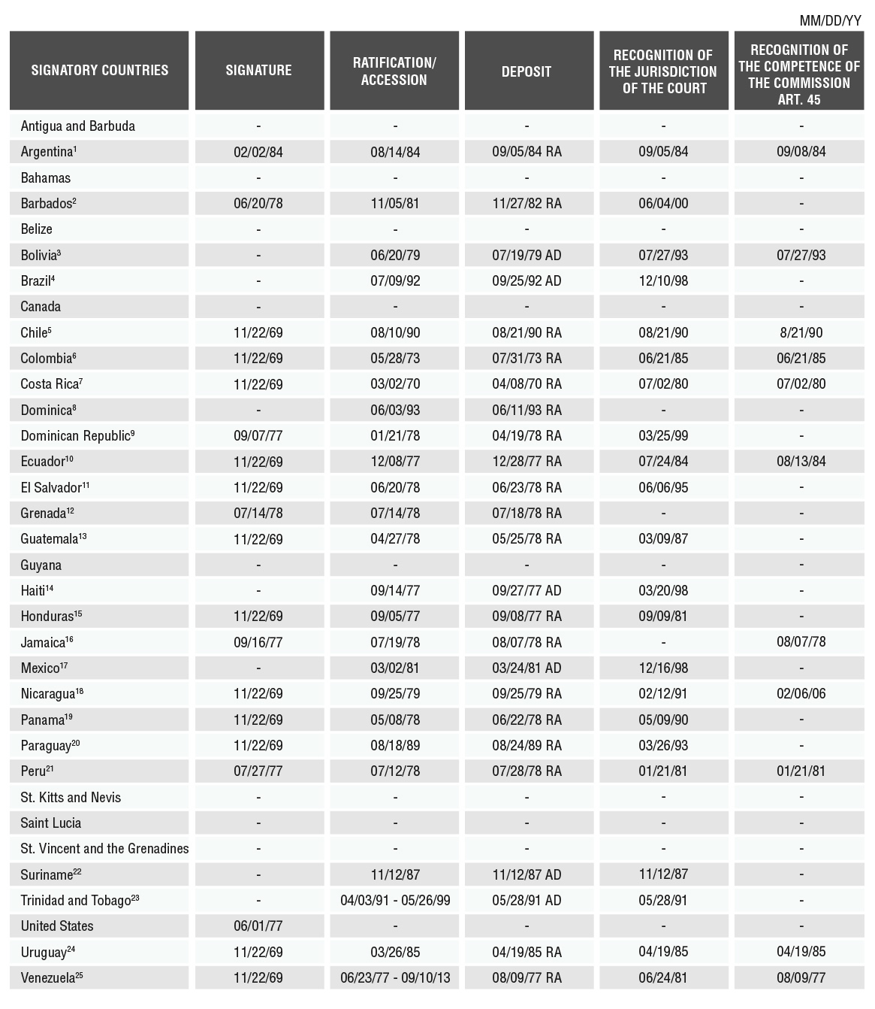
A-51: INTER-AMERICAN CONVENTION TO PREVENT AND PUNISH TORTURE

(Adopted at Cartagena de Indias, Colombia, on December 9, 1985, at
the fifteenth regular session of the General Assembly)

ENTRY INTO FORCE: 28 February 1987, in accordance with Article 22 of the Convention
DEPOSITARY: OAS General Secretariat (Original instrument and ratifications)
TEXT: OAS, Treaty Series, Nº 67
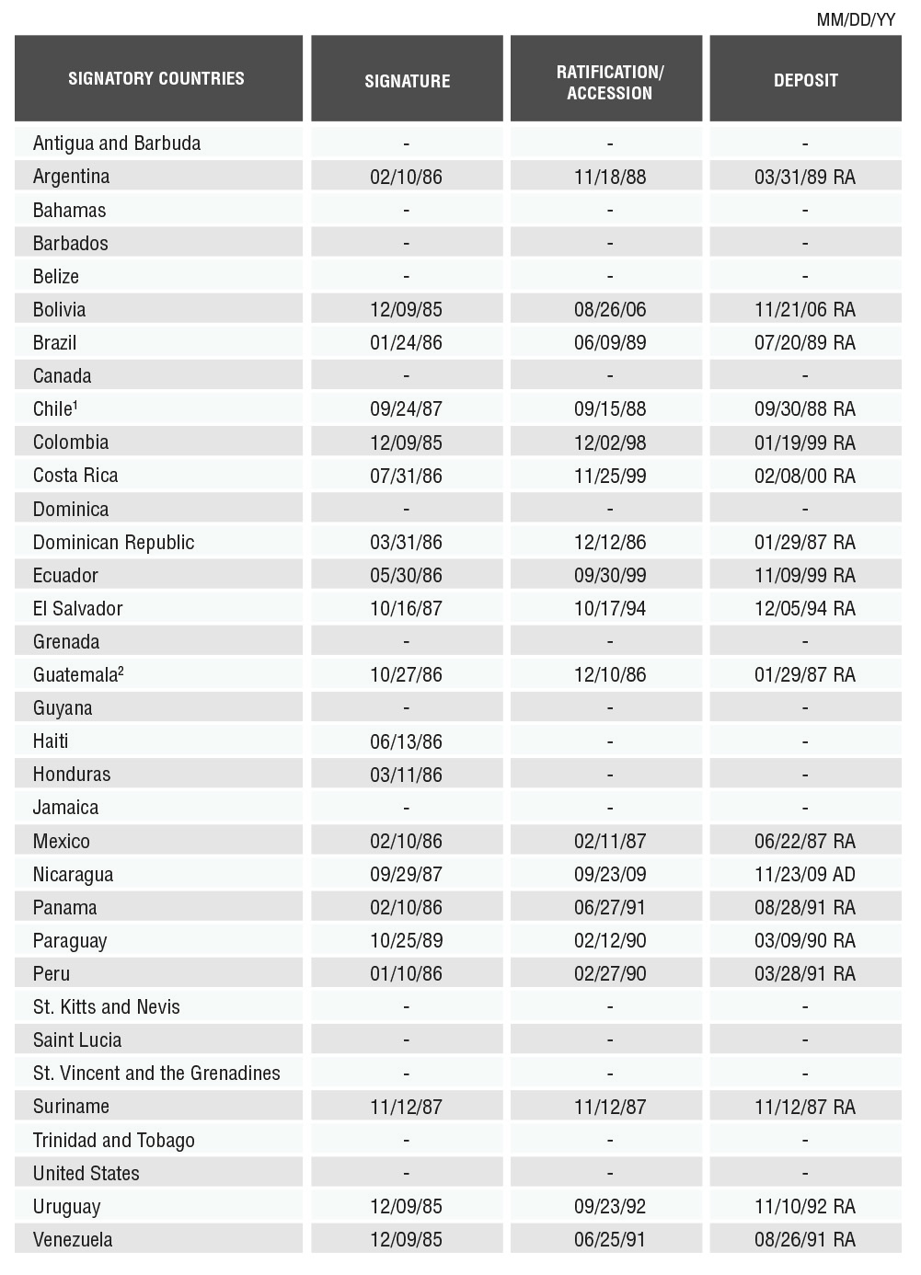
A-52: ADDITIONAL PROTOCOL TO THE AMERICAN CONVENTION
ON HUMAN RIGHTS IN THE AREA OF ECONOMIC, SOCIAL AND CULTURAL RIGHTS
"PROTOCOL OF SAN SALVADOR"

(Adopted at San Salvador, El Salvador on November 17, 1988, at
the eighteenth regular session of the General Assembly)

ENTRY INTO FORCE: November 16, 1999
DEPOSITORY: OAS General Secretariat (Original instrument and ratifications)
TEXT: OAS. Treaty Series, Nº 69
UN REGISTRATION:
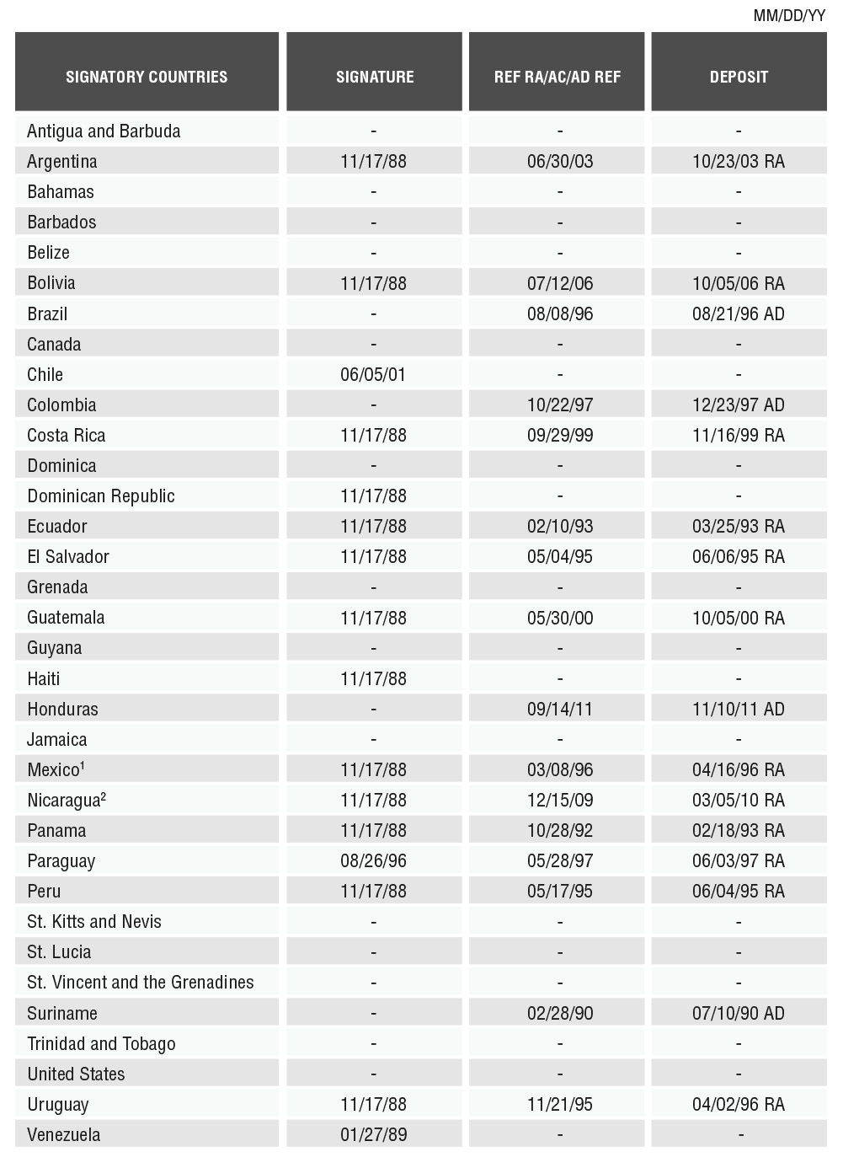
A-53: PROTOCOL TO THE AMERICAN CONVENTION ON HUMAN RIGHTS
TO ABOLISH THE DEATH PENALTY

(Adopted at Asunción, Paraguay, on June 8, 1990, at the
twentieth regular session of the General Assembly)

ENTRY INTO FORCE: August 28, 1991, in accordance with Article 4 of the Convention
DEPOSITORY: OAS General Secretariat (Original instrument and ratifications).
TEXT: OAS, Treaty Series, Nº 73.
UN REGISTRATION:
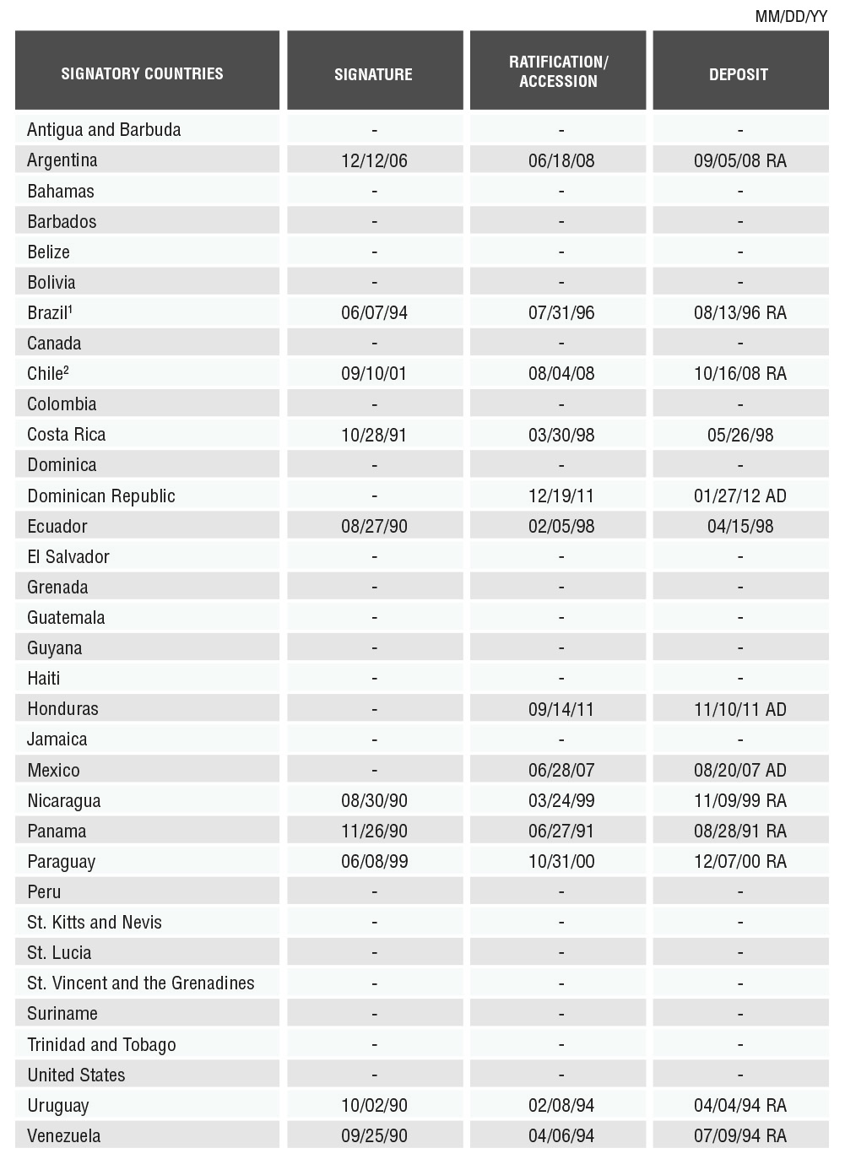
A-61: INTER-AMERICAN CONVENTION ON THE PREVENTION,
PUNISHMENT AND ERADICATION OF VIOLENCE AGAINST WOMEN
"CONVENTION OF BELÉM DO PARÁ"

(Adopted at Belém do Pará, Brazil, on June 9, 1994,
at the twenty fourth regular session of the General Assembly)

ENTRY INTO FORCE: March 5, 1995, in accordance with Article 21 of the Convention
DEPOSITARY: General Secretariat OAS (Original instrument and ratifications)
TEXT
UN REGISTRATION:
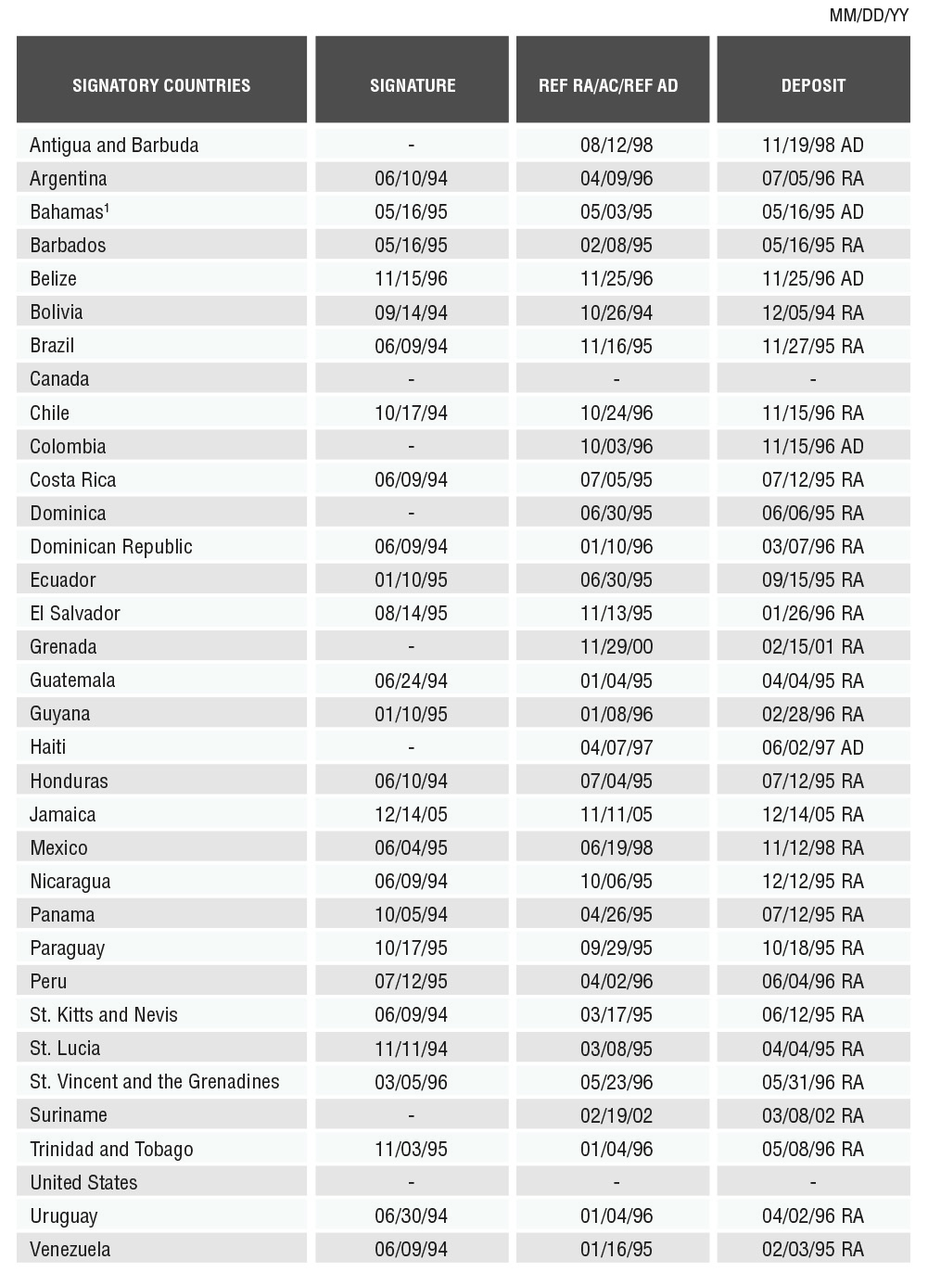
A-60: INTER-AMERICAN CONVENTION ON FORCED DISAPPEARANCE OF PERSONS

(Adopted at Belém do Pará, Brazil, on June 9, 1994, at the
twenty fourth regular session of the General Assembly)

ENTRY INTO FORCE: March 28, 1996, in accordance with Article XX of the Convention
DEPOSITORY: OAS General Secretariat (Original instrument and ratifications)
TEXT:
UN REGISTRATION:
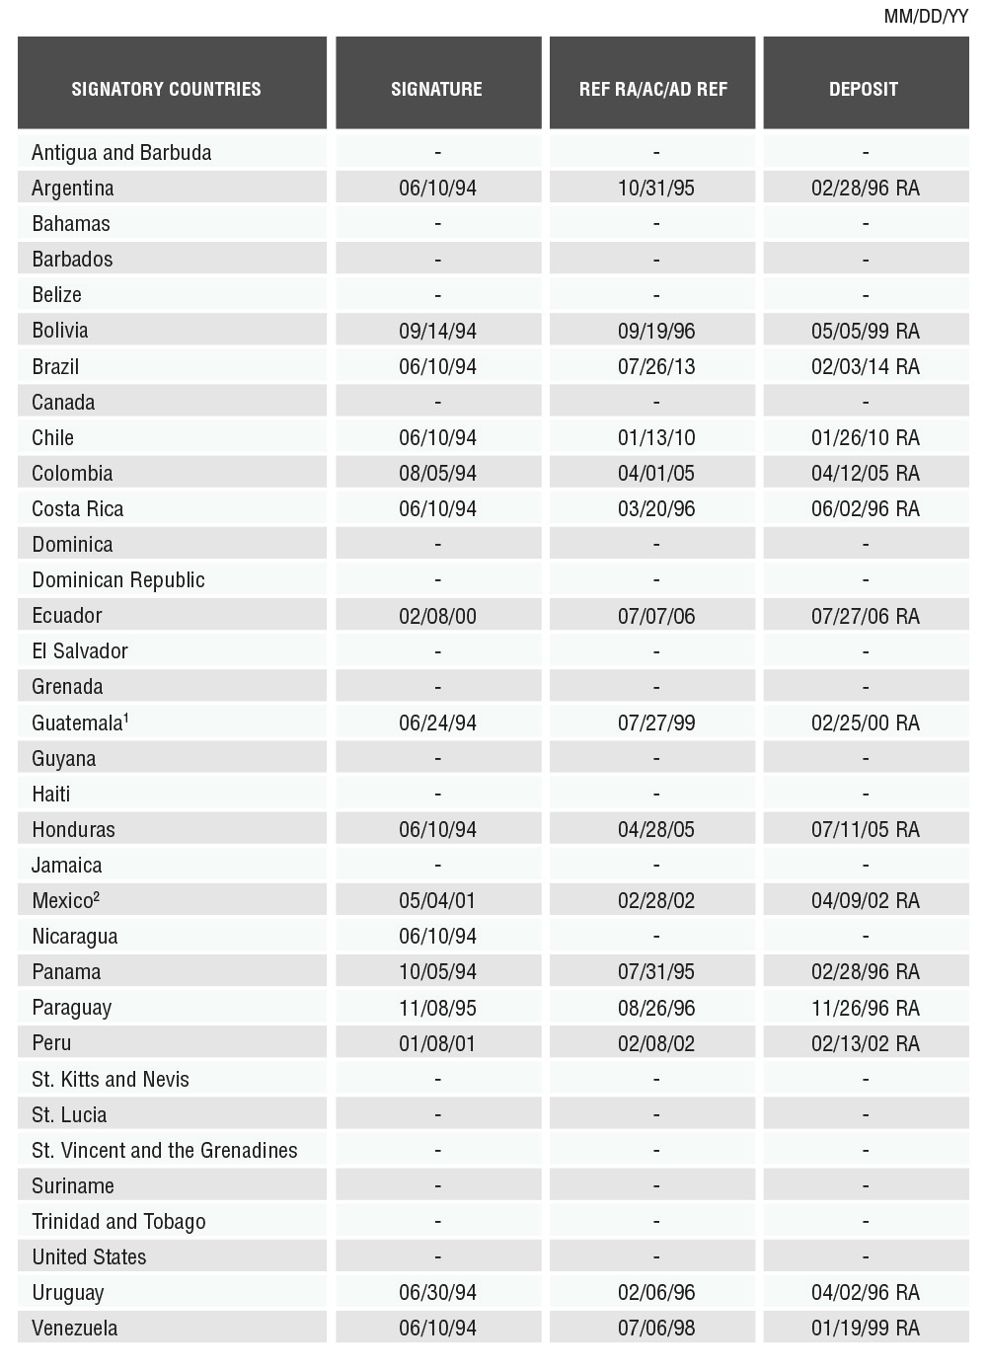
A-65: INTER-AMERICAN CONVENTION ON THE ELIMINATION OF ALL FORMS OF DISCRIMINATION AGAINST PERSONS WITH DISABILITIES

(Adopted at Guatemala City, Guatemala on June 7, 1999, at the
twenty-ninth regular session of the General Assembly)

ENTRY INTO FORCE: September 14, 2001
DEPOSITORY: OAS General Secretariat (Original instrument and ratifications)
TEXT:
UN REGISTRATION:
SIGNATORY COUNTRIES | SIGNATURE | REF RA/AC/REF AD | DEPOSIT
Antigua and Barbuda | - | - | -
Argentina | 06/08/99 | 09/28/00 | 01/10/01 RA
Bahamas | - | - | -
Barbados | - | - | -
Belize | - | - | -
Bolivia | 06/08/99 | 02/27/03 | 05/30/03 RA
Brazil | 06/08/99 | 07/17/01 | 08/15/01 RA
Canada | - | - | -
Chile | 06/08/99 | 12/04/01 | 02/26/02 RA
Colombia | 06/08/99 | 12/04/03 | 02/11/04 RA
Costa Rica | 06/08/99 | 12/08/99 | 02/08/00 RA
Dominica | 06/08/99 | - | -
Dominican Republic | 06/08/99 | 12/28/06 | 02/05/07 RA
Ecuador | 06/08/99 | 03/01/04 | 03/18/04 RA
El Salvador | 06/08/99 | 01/15/02 | 03/08/02 RA
Grenada | - | - | -
Guatemala | 06/08/99 | 08/08/02 | 01/28/03 RA
Guyana | - | - | -
Haiti | 06/08/99 | 05/29/09 | 09/03/09
Honduras | - | 09/14/11 | 11/10/11 AD
Jamaica | - | - | -
Mexico | 06/08/99 | 12/06/00 | 01/25/01 RA
Nicaragua | 06/08/99 | 07/15/02 | 11/25/02 RA
Panama | 06/08/99 | 01/24/01 | 02/16/01 RA
Paraguay | 06/08/99 | 06/28/02 | 10/22/02 RA
Peru | 06/08/99 | 07/10/01 | 08/30/01 RA
St. Kitts and Nevis | - | - | -
St. Lucia | - | - | -
St. Vincent and the Grenadines | - | - | -
Suriname | - | - | -
Trinidad and Tobago | - | - | -
United States | - | - | -
Uruguay | 06/08/99 | 05/24/01 | 07/20/01 RA
Venezuela | 06/08/99 | 06/06/06 | 09/28/06 RA
A-68: INTER-AMERICAN CONVENTION AGAINST RACISM, RACIAL DISCRIMINATION
AND RELATED FORMS OF INTOLERANCE

(Adopted at La Antigua, Guatemala on June 5, 2013, at the
forty-third regular session of the General Assembly)

ENTRY INTO FORCE: the thirtieth day after the date of deposit of the second instrument of ratification or accession to the Convention in the General Secretariat of the Organization of American States
DEPOSITORY: OAS General Secretariat (Original instrument and ratifications)
TEXT:
UN REGISTRATION:
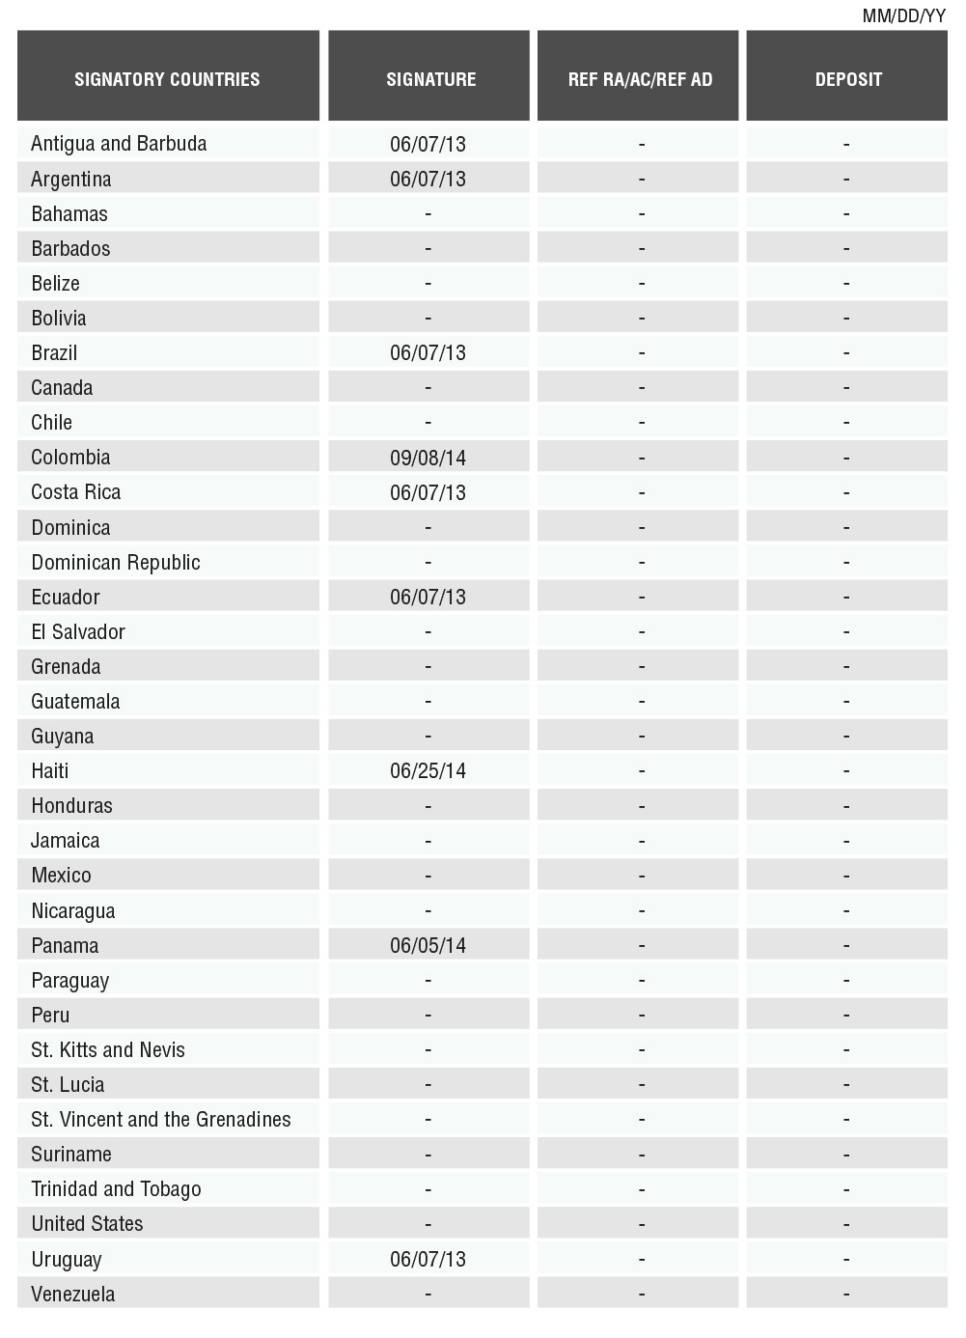
A-69: INTER-AMERICAN CONVENTION AGAINST ALL FORMS OF DISCRIMINATION
AND INTOLERANCE

(Adopted at La Antigua, Guatemala on June 5, 2013, at the
forty-third regular session of the General Assembly)

ENTRY INTO FORCE: the thirtieth day after the date of deposit of the second instrument of ratification or accession to the Convention in the General Secretariat of the Organization of American States
DEPOSITORY: OAS General Secretariat (Original instrument and ratifications)
TEXT:
UN REGISTRATION:

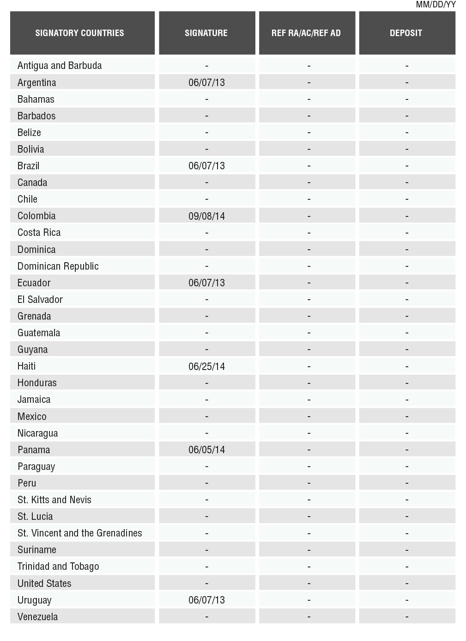

For example, IACHR, Annual Report 2013, Chapter IV(A)(2), Overview on universal ratification, incorporation of standards, conventionality control and compliance with IACHR’s recommendations and decisions, paras. 56-71; IACHR, Annual Report 2012, Introduction, OEA/Ser. L/V/II.147 Doc. 1, March 5, 2013, para. 19; IACHR, Annual Report 2010, Introduction, OEA/Ser. L/V/II. Doc. 5 corr. 1, March 7, 2011, para. 21.
IACHR, Annual Report 2013, Chapter IV(A)(2), Overview on universal ratification, incorporation of standards, conventionality control and compliance with IACHR’s recommendations and decisions, para. 56.
IACHR, Strategic Plan 2011-2015, Part I, page 41.
IACHR, Strategic Plan 2011-2015, Part I, page 36.
See for example, IACHR, Press Release, No. 62/07, IACHR President urges States to Ratify Human Rights Treaties, December 18, 2007; IACHR, Press Release, No. 40/08, IACHR Congratulates Argentina for Ratifying All Inter-American Human Rights Treaties, September 10, 2008. The nine treaties that make up the inter-American system of human rights are: American Convention on Human Rights (1969) Additional Protocol to the American Convention in the Area of Economic, Social and Cultural Rights (1988) Protocol to the American Convention on Human Rights to Abolish the Death Penalty (1990) Inter-American Convention to Prevent and Punish Torture (1985) Inter-American Convention on Forced Disappearance of Persons (1994) Inter-American Convention on the Prevention, Punishment and Eradication of Violence against Women (1994) Inter-American Convention on the Elimination of All Forms of Discrimination against Persons with Disability (1999) Inter-American Convention against All Forms of Discrimination and Intolerance (2013) Inter-American Convention against Racism, Racial Discrimination and Related Forms of Intolerance (2013)
Strengthening of the Inter-American Human Rights System Pursuant to the Mandates Arising from the Summits of the Americas, AG/RES. 2675 (XLI-O/11), June 7, 2011, operative paragraph 1(a); Fifth Summit of the Americas, Port of Spain, Trinidad and Tobago, Declaration of Commitment of Port of Spain, April 17-19, 2009, para. 83; Third Summit of the Americas, Quebec City, Canada, April 20-22, 2001, Action Plan, page 6. In turn, at the global level within the framework of the Vienna Declaration and Programme of Action, the States urged all States to ratify all human rights treaties without reservations. Vienna Declaration and Programme of Action, World Conference on Human Rights, June 14-25, 1993, A/CONF.157/23, July 12, 1993), Section I, para. 26, Section II, paras. 4-5.
For a general description of the process, see, IACHR, Press Release No. 19/13, IACHR Approves Reform of its Rules of Procedure, Policies and Practices,, March 19, 2013; IACHR, Annual Report 2012, Introduction, Chapter I(IV): The Reform Agenda of the IACHR, paras. 29-44. The IACHR has made significant efforts to ensure the transparent and participatory nature of this process of reform, receiving inputs from the OAS Member States, civil society, victims, representatives from academia, and other users of the inter-American system of human rights. The process included discussion forums, public consultations, and hearings for the purpose of receiving opinions, inputs, and experiences from all interested parties.
IACHR, Resolution 1/2013, March 19, 2013, page 16, section I, paragraph A (verifying that the IACHR will include in the revision of its Strategic Plan the promotion of universal ratification of the American Convention and other inter-American human rights instruments and their optional clauses as an institutional priority).
In the preparation of this report, the IACHR has in part drawn upon the feedback it received during its reform process between 2011 and 2013, and the answers to the questionnaire circulated with a view to preparation of Chapter IV(A) of the 2013 annual report, which concerned the matter of universality. The questionnaire was answered by the States of Argentina, Colombia, Costa Rica, Guatemala, Honduras, Jamaica, Mexico and Uruguay. Also taken into consideration was all the background of the IACHR and information received in individual petitions and cases, precautionary measures, thematic hearings, visits and when implementing the other mechanisms of the inter-American system, as well as the judgments of the Inter-American Court.
The World Conference on Human Rights reaffirmed the solemn commitment of all States to fulfil their obligations to promote universal respect for, and observance and protection of, all human rights and fundamental freedoms for all in accordance with the international instruments. It held that the “universal nature of these rights and freedoms is beyond question.” In keeping with these principles, the World Conference asked all the member states to ratify and accede to all international human rights instruments, with the aim of their universal acceptance. Vienna Declaration and Programme of Action. World Conference on Human Rights, June 14-25, 1993, A/CONF.157/23, July 12, 1993, paragraphs 1 (Section I) and 4 (Section II).
Regarding this issue, the IACHR has consistently recommended to the States that they make concrete, specific efforts to guarantee, on the one hand, the universality of the inter-American human rights system and, on the other, initiatives to comply with the decisions, recommendations, and orders from both the IACHR and the Inter-American Court of Human Rights.
. IACHR, Legal Standards Related to Gender Equality and Women’s Rights in the Inter-American Human Rights System: Development and Application, OEA/Ser. L./V/II.143 Doc. 60, November 3, 2011, paragraph 13.
. Vienna Declaration and Programme of Action, World Conference on Human Rights, June 14-25, 1993, A/CONF.157/23, July 12, 1993, para. 5.
See, for example, Inter-American Democratic Charter, Approved in the first plenary session of the OAS General Assembly, on September 11, 2001, Articles 7 and 9; Introduction to Resolution 618(XII-082) of the OAS General Assembly; IACHR, Annual Report, 1990-1991, Chapter V, Section III. Annual Report 1990-1991, Chapter V, Section III. Human Rights, Political Rights, and Representative Democracy in the Inter-American System. The States have themselves recognized in the context of the Summits of the Americas the universality, indivisibility, and interdependence of human rights as fundamental to the functioning of democratic societies. Fifth Summit of the Americas, Port of Spain, Trinidad and Tobago, Declaration of Commitment of Port of Spain, April 17-19, 2009, para. 82; Third Summit of the Americas, Quebec City, Canada, April 20-22, 2001, Action Plan, page 5.
The IACHR also believes that ratification makes significant contributions to the development of a democracy and a culture of human rights at the national level, a fundamental aspect for the prevention and non-repetition of human rights violations. In the past, it has observed how: The democracies must be strengthened through a human rights culture in which persons who are under the jurisdiction of the Member States of the Organization are convinced that their rights are not at the pleasure of their governments but rather an obligation that can be demanded of their States through effective access to justice. They must be consolidated through transparent, free, and authentic electoral processes and by strengthening the independence of the different branches of government from political sectors or de facto powers. They must ensure that unmet social demands do not attach themselves to violent solutions but are resolved under the rule of law. It is a fundamental challenge to ensure that humans are aware of their civil, political, economic, social, and cultural rights and may rely on democratic institutions to demand and exercise them. See, IACHR, Annual Report 2012, Chapter I, Introduction, paragraph 10.
Final Act of the Fifth Meeting of Consultation of Ministers of Foreign Affairs in Santiago, Chile, August 12-18, 1959; rev., corr., August 18, 1959; page. 5. http://www.oas.org/consejo/MEETINGS%20OF%20CONSULTATION/Actas/Acta%205.pdf
Presentation by Tracy Robinson of the 2013 IACHR Annual Report, April 23, 2014.
IACHR, Report No. 80/11, Case 12.626, Jessica Lenahan (Gonzales) et al., United States, July 21, 2011, para. 117.
See, Rules of Procedure of the Inter-American Commission on Human Rights (2013), Articles 51 and 52, which empower the Commission to receive and examine petitions alleging the violation of rights enshrined in the American Declaration in connection with OAS Member States that are not party to the American Convention; Statute of the Inter-American Commission on Human Rights (1979), Article 1, which establishes that the Commission was created “to promote the observance and defense of human rights” and defines human rights as those set forth in the American Declaration and in the American Convention.
See I/A Court H.R., Advisory Opinion OC-10/89 "Interpretation of the Declaration of the Rights and Duties of Man within the Framework of Article 64 of the American Convention on Human rights,” July 14, 1989, Ser. A, No. 10 (1989), para. 45. In that opinion, the Court maintained that “for the member States of the Organization, the Declaration is the text that defines the human rights referred to in the Charter.”
See, as a reference, the Statute of the Inter-American Commission on Human Rights (1979), Article 1, which establishes that the Commission was created “to promote the observance and defense of human rights” and defines human rights as those set forth in the American Declaration and in the American Convention. See also, Articles 18 and 20 of the Statute and the American Convention on Human Rights, Article 29 (d), which provides that no provision of this Convention shall be interpreted in the sense of “excluding or limiting the effect that the American Declaration of the Rights and Duties of Man and other international acts of the same nature may have.” See also, Rules of Procedure of the Inter-American Convention on Human Rights (2009), Articles 51 and 52, which empower the Commission to receive and examine petitions alleging the violation of rights enshrined in the American Declaration with respect to OAS Member States that are not parties to the American Convention.
See, Annex, Table, State of Ratifications and Signatures, OAS Charter (Basic Documents 2014).
. See, Annex, Table, State of Ratifications and Signatures, American Convention on Human Rights (Basic Documents 2014).
. See, Annex, Table, State of Acceptance of the Competency of the Inter-American Court, American Convention on Human Rights (Basic Documents 2014).
. This group includes Argentina, Costa Rica, Ecuador, Mexico, Panama, Paraguay and Uruguay. See, Annex, Tables, State of Ratifications and Signatures, Nine Inter-American Human Rights Treaties (Basic Documents 2014). The Commission also observes that the Inter-American Conventions against All Forms of Discrimination and Intolerance and against Racism, Racial Discrimination and Related Forms of Intolerance have not been factored into the data, since they were only recently adopted. However, the Commission recognizes the signature of Argentina, Brasil, Colombia, Dominica, Haiti, Nicaragua and Trinidad and Tobago of the Inter-American Convention against all Forms of Discrimination and Intolerance. It also recognizes the signature of Antigua and Barbuda, Argentina, Brasil, Colombia, Costa Rica, Ecuador, Haiti, Panama and Uruguay of the Inter-American Convention against Racism, Racial Discrimination and Related Forms of Intolerance, as a first step towards ratification of these two instruments.
. IACHR, Strategic Plan 2011-2015, Part I, p. 36; Annual Report 2013, Chapter IV(a), Universal ratification of human rights treaties, paragraph 58.
IACHR, Annual Report 2013, Chapter IV(A)(2), Overview on universal ratification, incorporation of standards, conventionality control and compliance with the IACHR’s recommendations and decisions, paragraph 62.
. The IACHR published press releases 10/98 and 62/13 to express its concern over the decision by Trinidad and Tobago and Venezuela to denounce the American Convention. These press releases are available at: http://www.IACHR.org/Comunicados/English/1998/Press10-14.htm#10 http://www.oas.org/en/iachr/media_center/PReleases/2013/064.asp
. IACHR, Annual Report 2013, Chapter IV(A)(2), Overview on universal ratification, incorporation of standards, conventionality control and compliance with the IACHR’s recommendations and decisions, paragraph 63.
. IACHR, Annual Report 2013, Chapter IV(A)(2), Overview on universal ratification, incorporation of standards, conventionality control and compliance with the IACHR’s recommendations and decisions, paragraph 63.
. See, IACHR, Press Releases Nos. 25/05, 12/05, 47/06, 33/06, 1/06, 40/08, and 12/12.
IACHR, Press Release, No. 19/13, IACHR Approves Reform of its Rules of Procedure, Policies and Practices, March 19, 2013. The IACHR has emphasized that its functions include promoting compliance with decisions, ensuring the victims’ access to the inter-American system as a supplemental remedy, administering the petitions system effectively and efficiently, granting precautionary measures, developing thematic approaches, keeping current with the human rights situation in the region, responding to the needs of groups that throughout history have been marginalized, promoting human rights, disseminating knowledge of the legal standards established by the inter-American system, as well as other functions. See in general terms, the IACHR Strategic Plan for 2011-2015.
IACHR, Annual Report 2013, Chapter IV(A)(2), Overview on universal ratification, incorporation of standards, conventionality control and compliance with IACHR’s recommendations and decisions, para. 56.
See, for example, Bogota Declaration, September 11, 2012.
See, for example, Response to the questionnaire from the Human Rights Center of La Montaña, Mexican Commission for the Defense and Promotion of Human Rights, and the PRODH Center - Mexico.
See, for example, Statistics on petitions submitted by country. Annual Reports of the IACHR, 2009-2013, available at: http://www.oas.org/es/IACHR/informes/anuales.asp
See as a reference, IACHR, Legal Standards Related to Gender Equality and Women’s Rights in the Inter-American System of Human Rights: Development and Application, OEA/Ser. L./V/II.143 Doc. 60, November 3, 2011 http://www.oas.org/en/iachr/women/docs/pdf/REGIONAL%20STANDARDS.pdf; IACHR, Indigenous and Tribal People’s Right over Their Ancestral Lands and Natural Resources: Norms and Jurisprudence of the Inter-American System of Human Rights, OEA/Ser. L./V/II. Doc. 56/09, December 30, 2009. http://www.oas.org/en/iachr/indigenous/docs/pdf/AncestralLands.pdf.
See, Protocol of San Salvador (1988); Convention of Belém do Pará (1994); Inter-American Convention on the Elimination of All Forms of Discrimination against Persons with Disabilities (1999); Inter-American Convention against All Forms of Discrimination and Intolerance (2013); Inter-American Convention against Racism, Racial Discrimination, and Related Forms of Intolerance (2013).
See, Protocol to the American Convention on Human Rights to Abolish the Death Penalty (1990); Inter-American Convention to Prevent and Punish Torture (1985); Inter-American Convention on Forced Disappearance of Persons (1994).
The IACHR has emphasized in the past how human rights defenders, journalists, persons deprived of liberty, women, indigenous and tribal peoples, lesbians, gays, and trans, bisexual and intersex persons (LGBTI), migrants, and members of other groups in situations of imminent risk have had their lives, integrity, and other fundamental rights saved thanks to the adoption of precautionary measures. IACHR, Annual Report 2012, Introduction, OEA/Ser. L/V/II.147 Doc. 1, March 5, 2013, Introduction, para. 8.
See in general, http://www.oas.org/es/IACHR/actividades/visitas.asp (Description of on-site and working visits conducted by the IACHR between 1965 and December 2013) [in Spanish].
See, Presentation of the 2013 Annual Report by the President of the IACHR, Tracy Robinson, to the Committee on Juridical and Political Affairs of the Permanent Council of the Organization of American States, Washington, DC, April 23. 2014 available at, http://www.oas.org/en/iachr/activities/speeches/23.04.14.asp
The following experts from countries that have not ratified the American Convention are serving or have served as Commissioners: James Cavallaro (United States, 2014 –Present); Rose Marie-Antoine, current Vice-Chair (Santa Lucia and Trinidad and Tobago 2012-Present), Dinah Shelton (United States 2010-2013), Clare K. Roberts (Antigua and Barbuda, 2002-2009), Paolo Carozza (United States, 2006-2010), Robert Goldman (United States, 1996-2003); Michael Reisman (United States, 1990-1995); John Reese Stevenson (United States, 1988-1990); Bruce McColm (United States, 1984-1988); Tom J. Farer (United States, 1976-1983); Robert F. Woodward (United States, 1972-1976); Durward V. Sandifer (United States, 1960-1972), among others. Professor Thomas Buergenthal, a United States citizen, served as a Judge on the Inter-American Court between 1979 and 1991 after being nominated by Costa Rica.
See, for example, IACHR, Thematic Hearings, Impact of Stand Your Ground Laws on Minorities in the United States, 150th Regular Session, March 25, 2014; Human Rights Situation of Detainees at Guantánamo Naval Base, United States, 149th Session, October 28, 2013; Human Rights Situation of LGBTI Persons in Canada, 150th Regular Session, March 27, 2014; Complaints regarding Missing and Murdered Indigenous Women and Girls in British Columbia, Canada, 144th Regular Session, March 28, 2012; Human Rights Situation of Journalists in Cuba, 150th Regular Session, March, 25, 2014; Situation of Human Rights Defenders in Cuba, 149th Regular Session, October 29, 2013; Human Rights Situation of LGBTI Persons in Belize, 150th Regular Session, March 28, 2014; Situation of the Death Penalty in Belize, 116th Session, October 18, 2002; Reports of Discrimination and Violence against Children in Guyana, Based on Sexual Orientation and Gender Identity, 149th Session, October 28, 2013; Human Rights Situation in Guyana, 108th Session, October 18, 2002.
For example, activities organized by the IACHR in countries that have not ratified the American Convention have included: - Organization of training seminars for CARICOM at the George Washington University School of Law, for Caribbean diplomats and government officials in Washington, DC (October 2012, 2013) - Launch of the Report on the Situation of People of African Descent in the Americas by the Rapporteur on the Rights of People of African Descent and Against Racial Discrimination during the 33rd meeting of the CARICOM Heads of Government in Santa Lucia (July 2012) - Organization of a subregional meeting on juvenile criminal justice for the Eastern Caribbean and the Bahamas (May 2009) - Workshop in St. John’s, Antigua to promote ratification of international and regional human rights instruments (April, 2006) - Special Forum on Race, Discrimination, and Economic, Social, and Cultural Rights in North America, IACHR, McGill University, Montreal, Canada (November 22-23, 2013). - Seminar on the inter-American system of human rights for public officials and civil society in Belize (July 19-20, 2011), organized in collaboration with the Caribbean Human Rights Network, the Inter-American Institute of Human Rights, the Commonwealth Secretariat, under the auspices of the Government of the United Kingdom and Northern Ireland.
For example, the Commission undertook the following working visits to the United States in 2014 : Working visit to monitor the human rights situation of unaccompanied children and families who have crossed the southern border of the United States (September 29-October 2, 2014); and Working visit to New York to obtain information related to the situation of persons under 18 yeas of age accused, judged, sanctioned, and imprisoned as adults and the reclusion conditions of youth in prisons and penitentiary centers (April 7-10, 2014). The Commission has also been able to undertake the following working visits to the United States, among others: - Visit to Immigrant Detention Centers in Arizona and Texas (July20-24, 2009) with the goal of collecting information from the authorities in charge of detentions, persons detained, and representatives from civil society organizations in respect to compliance with human rights norms in the fields of immigration, detention, and due process. - Visit to El Paso, Texas (July 7-9, 1999) to collect information in relation to immigration and asylum processes in this region. - Visit to Los Angeles and San Diego, California (July 7-9, 1998) to study the situation of migrant workers and their families (July 7-9, 1998). - Visit to Marksville and Amite, Louisiana to verify the prison conditions of the "Mariel Cubans" (December 9-10, 1996) - Visit to Allenwood, Pennsylvania of verification of prison conditions of the “Mariel Cubans” (April 26, 1996) - Visit to the Penitentiary of Leavenworth, Kansas (May 30, 1995) - Visit to the Federal Penitentiary of Lompoc, California to verify the detention conditions of the “Mariel Cubans” (May 3-5, 1995) - Visit to the center of Haitian refugees in Brooklyn, New York (August 5-6, 1982) - Visit to the detention centers of Haitian refugees in Florida and Puerto Rico (June 28-29, 1982) - Visit to the Cuban refugees in Miami, Florida (January 2, 1963) The Commission also undertook a recent working visit to Canada to examine the disappearance and murders of indigenous women in British Columbia (August 6-9, 2013). Between October 20 and 22, 1997, the Commission had visited Canada to observe the conditions of refugees. The Commission also undertook an in loco visit to Bahamas between May 22 and 27, 1994.
. See, in general, IACHR, Access to Justice for Women Victims of Violence in the Americas, OEA/Ser. L/V/II. Doc. 68, January 20, 2007; IACHR, Access to Justice as a Guarantee of Economic, Social, and Cultural Rights. A Review of the Standards Adopted by the Inter-American System of Human Rights, OEA/Ser. L/V/II.129, September 7, 2007.
. See, for example, Statistics on petitions, presented by country, Annual Reports of the IACHR 2009-2013, available at http://www.oas.org/en/iachr/reports/annual.asp. In 2013, the IACHR received 2061 petitions from various countries.
. IACHR, Strategic Plan 2011 – 2015, p. 37.
IACHR, Strategic Plan 2011 – 2015, p. 58.
. See, for example, I/A Court H.R., Case of González et al. (“Cotton Field”) v. Mexico. Preliminary Objection, Merits, Reparations and Costs. Judgment of November 16, 2009. Series C No. 205; I/A Court H.R. Case of the Dos Erres Massacre v. Guatemala. Preliminary Objection, Merits, Reparations and Costs. Judgment of November 24, 2009. Series C No. 211; I/A Court H.R. Case of the Sawhoyamaxa Indigenous Community v. Paraguay. Judgment of March 29, 2006. Series C. No. 146.
. See, for example, I/A Court H.R. Case of the Rochela Massacre. Judgment of May 11, 2007. Series C No. 163; I/A Court H.R. Case of Velásquez Rodríguez v. Honduras. Judgment of July 29, 1988. Series C No. 4.
. See, for example, I/A Court H.R. Case of La Cantuta v. Peru. Judgment of November 29, 2006. Series C No. 162; I/A Court H.R. Case of Barrios Altos v. Peru. Judgment of March 14, 2001. Series C No. 75.
. See, for example, I/A Court H.R. Case of the Mayagna (Sumo) Awas Tingni Indigenous Community v. Nicaragua. Preliminary Objections. Judgment of February 1, 2000. Series C No. 66; I/A Court H.R., Case of Fernández Ortega et al. v. Mexico. Preliminary Objection, Merits, Reparations and Costs. Judgment of August 30, 2010. Series C No. 215; I/A Court H.R. Case of Rosendo Cantú v. Mexico. Preliminary Objection, Merits, Reparations and Costs. Judgment of August 31, 2010. Series C No. 216; I/A Court H.R. Case of Atala Riffo and Daughters v. Chile. Merits, Reparations and Costs. Judgment of February 24, 2012. Series C No. 239; I/A Court H.R. Case of the “Street Children” (Villagrán Morales et al.) v. Guatemala. Preliminary Objections. Judgment of September 11, 1997. Series C No. 32; I/A Court H.R. Case of the Girls Yean and Bosico v. the Dominican Republic. Judgment of September 8, 2005. Series C No. 130.
. See, for example, I/A Court H.R. Case of Radilla Pacheco v. Mexico. Preliminary Objections, Merits, Reparations and Costs. Judgment of November 23, 2009. Series C No. 209; I/A Court H.R. Case of Yatama v. Nicaragua. Judgment of June 23, 2005. Series C No. 127; I/A Court H.R. Case of Claude Reyes et al. v. Chile. Judgment of September 19, 2006. Series C No. 151.
As pointed out by Brian Tittemore, formerly Principal Specialist at the Inter-American Commission on Human Rights: The lack of uniformity in obligations undertaken by governments within the inter-American human rights system has presented challenges to the Commission and the Court in attempting to recognize and promote maximum and universally applicable human rights standards among all OAS Member States, while at the same time respecting distinctions in the treaty commitments explicitly undertaken by each individual state. The Caribbean region, having all three categories of Member States, provides a microcosm of the system’s legal disparities, which in turn affects the options available to the Commission and the Court in processing complaints that may raise issues common to some or all of the countries of the region, including the mandatory death penalty. Brian D. Tittemore, The Mandatory Death Penalty in the Commonwealth Caribbean and the Inter-American Human Rights System: An Evolution in the Development and Implementation of International Human Rights Protections, 13 Wm. & Mary Bill Rts. J. 445 (2004)
. On several occasions, the OAS General Assembly has urged OAS member states to follow up on IACHR recommendations, for example, in resolution AG/RES. 2672 (XLI-0/11), “Observations and Recommendations on the Annual Report of the IACHR” (operative paragraph 3.b). Moreover, in resolution AG/RES. 2675 (XLI-0/11), “Strengthening of the Inter-American Human Rights System Pursuant to the Mandates from the Summits of the Americas,” the Assembly instructed the Permanent Council to continue to consider ways to promote implementation of the recommendations of the IACHR by member states (operative paragraph 3.d).
. IACHR, Annual Report 2013, Chapter 2(D), Status of compliance in individual cases, paragraphs 35-1189.
. IACHR, Annual Report 2013, Chapter 2(D), Status of compliance in individual cases, paragraphs 35-1189.
. IACHR, Annual Report 2013, Chapter 2(D), Status of compliance in individual cases, paragraphs 35-1189.
See, for example, IACHR, Report No. 52/13, Cases 11.575, 12,333, and 12.341, Clarence Allen Lackey et al., Merits (Publication), United States, July 15, 2013; IACHR, Report No. 80/11, Case 12.626, Jessica Lenahan (Gonzales) et al., United States, July 21, 2011; IACHR, Report No. 8110, Case 12.562, Wayne Smith et al., Merits (Publication), July 12, 2010; IACHR, Report No. 78/11, Case 12.586, John Doe et al., Canada, Merits (Publication), July 21, 2011; IACHR, Report No. 61/08, Case 12.435, Gran Cacique Michael Mitchell, Canada, Merits (Publication), July 25, 2008; IACHR, Report No. 78/07, Case 12.265, Merits, Chad Roger Goodman, Bahamas, October 15, 2007; IACHR, Report No. 48/01, Case 12.067, Michael Edwards, Case 12.068, Omar Hall, Case 12.086, Brian Schroeter and Jeronimo Bowleg, Bahamas, April 4, 2001; IACHR, Report No. 40/04, Case 12.053, Merits, Maya Indigenous Communities of the Toledo District, Belize, October 12, 2004; IACHR, Report No. 81/07, Case 12.504, Merits, Daniel and Kornel Vaux, Guyana, October 15, 2007; IACHR, Report No. 67/06, Case 12.476, Merits, Oscar Elías Biscet et al., Cuba, October 21, 2006.
See, for example, IACHR, Report on Immigration in the United States: Detention and Due Process, OEA/Ser. L/V/II. Doc. 78/10, December 30, 2010; IACHR, Reports on the human rights situation in Cuba (1962, 1967, and 1970).
See, for example, IACHR, The Death Penalty in the Inter-American Human Rights System: from Restrictions to Abolition, OEA/Ser. L/V/II. Doc. 68, December 31, 2011.
See, for example, MC 255/13 - Robert Gene Garza, United States; MC 211/08 – Djamel Ameziane; MC 385-09 – 31 Undocumented Immigrants Residing in Atlanta, Georgia, United States; PM 259/02 – Detainees at the U.S. Military Base in Guantanamo; PM 410/13 - José Luis Zubmaguera Miranda and family, Cuba; PM 245/13 – Iván Hernández Carrillo, Cuba; PM 264/13 – Damas de Blanco, Cuba; PM 354/12 – Sonia Garro, Cuba; PM 155/13 - Caleb Orozco, Belize; PM 254/07 – AW, Guyana; 158/01 - Daniel Vaux and Cornel Vaux, Guyana; 11-98, Michael Edwards, Bahamas; Ikbal Iskander (Canada, February 19, 2002); Andrew Levi Harte (Canada, July 31, 1998).
See, for example: - Thematic hearings related to the United States: Human Rights Situation of Migrant and Refugee Children and Families in the United States, 153 Regular Period of Sessions; October 27, 2014; Human Rights Situation of Persons Deprived of Liberty in Texas, United States, 153 Regular Period of Sessions; October 27, 2014; Reports of Racism in the Justice System of the United States (Ex Officio), 153 Regular Period of Sessions, October 27, 2014; Impact of Stand Your Ground Laws on Minorities in the United States,, 150th Regular Session, March 25, 2014; Human Rights Situation of Detainees at Guantánamo Naval Base, United States, 149th Session, October 28, 2013; and others. - Thematic hearings related to Canada: Impact of Canadian Mining Activities on Human Rights in Latin America, 153 Period of Sessions, October 28, 2014; Human Rights Situation of LGBTI Persons in Canada, 150th Regular Session, March 27, 2014; Complaints regarding Missing and Murdered Indigenous Women and Girls in British Columbia, Canada, 144th Regular Session, March 28, 2012; and others. - Thematic hearings related to Cuba: Human Rights Situation of Persons Deprived of Liberty in Cuba, 153 Period of Sessions, October 27, 2014; Human Rights Situation of Journalists in Cuba, 150th Regular Session, March 25, 2014; Situation of Human Rights Defenders in Cuba, 149th Regular Session, October 29, 2013; and others. - Thematic Hearings related to Belize: General Situation of Human Rights in Belize, 152 Period of Sessions, August 12, 2014; Human Rights Situation of LGBTI Persons in Belize, 150th Regular Session, March 28, 2014; Situation of the Death Penalty in Belize, 116th Session, October 18, 2012; and others. - Thematic Hearings related to Guyana: Reports of Discrimination and Violence against Children in Guyana, Based on Sexual Orientation and Gender Identity, 149th Session, October 28, 2013; Human Rights Situation in Guyana, 108th Session, October 18, 2002.
For example, the IACHR received a response from the Human Rights Institute at the Colombia University School of Law in the United States indicating that the United States’ failure to ratify is a significant impediment to incorporation of inter-American human rights standards in domestic legislation, policies, and practices. They understand that to date there has been no formal or explicit reference to the inter-American standards in federal laws, regulations, and directives. They also assert that the concept of conventionality control to ensure that judges review the compliance of State measures with international human rights commitments has not been developed in the United States and no domestic mechanisms have been established to effectively implement the decisions and recommendations of the IACHR.
For example, the IACHR received a response to the questionnaire from the Seattle Human Rights Commission in the United States, asserting that there is no awareness in that state of the existence of the inter-American human rights standards, the work of the system’s bodies, and their relevance for the United States. They also lack a domestic entity with an explicit mandate to implement the human rights obligations contained in international treaties, in order to facilitate the implementation of those standards. In addition, they assert that when the operation of the inter-American system is explained, there are many doubts regarding the provisions of the American Declaration and its status different from a treaty ratified under international human rights law.
The Commission has received important information this year indicating that local governments in 11 jurisdictions throughout the United States have adopted resolutions recognizing the right to live free of domestic violence as a fundamental human right. Reports have been received on the adoption of such resolutions in in Albany, Baltimore, Boston, Buffalo, Cincinnati, Colorado, Miami Springs, Miami Dade, Montgomery County (Alabama), Seattle, and Washington, DC. For more details, see, http://www.wcl.american.edu/humright/center/dvresolutions.cfm The IACHR understands that a factor contributing to the adoption of these resolutions was the IACHR report on the merits report published in the Jessica Lenahan (Gonzalez) et al. case (2011), involving the United States, where the IACHR ruled for the first time on the nexus between domestic violence and the problem of discrimination under the American Declaration. It considers these resolutions positive efforts and good practice shedding light on the problem of domestic violence and promoting an adequate response to this serious human rights problem.
See, as a reference, the National Reports on Antigua and Barbuda, Bahamas, Belize, Canada, Cuba, the United States, Guyana, St. Kitts and Nevis, St. Lucia, and St. Vincent and the Grenadines under the Universal Periodic Review by the United Nations Human Rights Council, First Cycle.
See, Responses to questionnaire from the States of Argentina, Colombia, Costa Rica, Guatemala, Honduras, Jamaica, Mexico, and Uruguay.
See, Response to questionnaire form Argentina; I/A Court H.R., Kimel v. Argentina Case, Merits, Reparations, Costs, Judgment of May 2, 2008, Series C, No. 177.
See, for example, Responses to the questionnaire from Colombia, Guatemala, and Mexico.
The organization Jamaicans for Justice believes that the adoption of the Jamaican Charter of Fundamental Rights and Freedoms (Constitutional Amendment) Act reflects an effort on the part of the State to incorporate the inter-American standards in local laws. However, it states that although the “Charter is a step in the right direction, there are many gaps within the provisions that require amendment and/or challenge through litigation. Most notably the charter fails to protect the fundamental rights of all citizens of Jamaica, thereby undermining the inherent dignity of all persons. Further, the enactment of the Charter has not ushered in an era in Jamaica where Human Rights are recognized, respected and/or incorporated into the practices of State organs/agents when interacting with citizens of Jamaica.”
See, for example, responses to the questionnaire from Capital Humano y Alternativo (Perú), Asociación por los Derechos Civiles (Argentina), CENIDH (Nicaragua), Fundación Myrna Mack (Guatemala), Centro de Análisis Forense y Ciencias Aplicadas-CAFCA (Guatemala), Fundación para la Libertad de Prensa (Colombia), Jamaicans for Justice (Jamaica), REDNOVI (Guatemala), Comisión Mexicana de Derechos Humanos A.C. (México); Jorge Alfredo Martínez Reyes (México), Salvador Alberto Sosa Ocampo (México), María Margarita Buchelli (Colombia); Clínica de Direitos Humanos, Faculdade Damas (Brasil); Associacão Juízes para a Democracia (Brasil); Gabinete de Assessoria Jurídica às Organizações Populares – GAJOP (Brasil) and Red Latinoamericana y del Caribe para la Democracia (REDLAD).
For example, see questionnaire responses from Argentina, Costa Rica, Guatemala, and Mexico.
IACHR, Legal Standards Related to Gender Equality and Women’s Rights in the Inter-American Human Rights System: Development and Application, OEA/Ser. L./V/II.143 Doc. 60, November 3, 2011; Questionnaire response from the Civil Rights Association in Argentina.
See I/A Court H.R., Advisory Opinion OC-10/89, Interpretation of the Declaration of the Rights and Duties of Man within the Framework of Article 64 of the American Convention on Human Rights,, July 14, 1989, para. 12.
IACHR, Report on Immigration in the United States: Detention and Due Process, OEA/Ser. L/V/II. Doc. 78/10, December 30, 2010, para. 24.
IACHR, Report No. 80/11, Case 12.626, Jessica Lenahan (Gonzales) et al., United States, July 21, 2011, paras. 55, 106 and 115-121.
See I/A Court H.R., Advisory Opinion OC-10/89 "Interpretation of the Declaration of the Rights and Duties of Man within the Framework of Article 64 of the American Convention on Human Rights”, July 14, 1989, Ser. A Nº 10 (1989), paras. 35-45; James Terry Roach and Jay Pinkerton v. United States, Case 9647, Res. 3/87, 22 September 1987, Annual Report of the IACHR 1986-87, paras. 46-49. See also, IACHR, Report on Immigration in the United States: Detention and Due Process, OEA/Ser. L/V/II. Doc. 78/10, December 30, 2010, para. 30.
See I/A Court H.R., Advisory Opinion OC-10/89 "Interpretation of the Declaration of the Rights and Duties of Man within the Framework of Article 64 of the American Convention on Human Rights”, July 14, 1989, Ser. A Nº 10 (1989), paras. 35-45; James Terry Roach and Jay Pinkerton v. United States, Case 9647, Res. 3/87, 22 September 1987, Annual Report of the IACHR 1986-87, paras. 46-49.
Charter of the Organization of American States, Articles 3, 16, 51.
See e.g. OAS General Assembly Resolution 314, AG/RES. 314 (VII-O/77), June 22, 1977 (entrusting the Inter-American Commission with the preparation of a study to “set forth their obligations to carry out the commitments assumed in the American Declaration of the Rights and Duties of Man”); OAS General Assembly Resolution 371, AG/RES (VIII-O/78), July 1, 1978 (reaffirming its commitment to “promote the observance of the American Declaration of the Rights and Duties of Man”); OAS General Assembly Resolution 370, AG/RES. 370 (VIII-O/78), July 1, 1978 (referring to the “international commitments” of OAS member states to respect the rights recognized in the American Declaration of the Rights and Duties of Man).
IACHR, Report Nº 19/02, Case 12.379, Lare-Reyes et al. (United States), February 27, 2002, para. 46.
See I/A Court H.R., Advisory Opinion OC-10/89 "Interpretation of the Declaration of the Rights and Duties of Man within the Framework of Article 64 of the American Convention on Human Rights”, July 14, 1989, Ser. A Nº 10 (1989), para. 45 (The Court held that “for the member states of the Organization, the Declaration is the text that defines the human rights referred to in the Charter”).
See, for example, Francisco J. Rivera Juaristi, U.S. Exceptionalism and the Strengthening Process of the Inter-American Human Rights System, Human Rights Brief, Volume 20, Issue 2, Winter 2003; Joseph Diab, United States Ratification of the American Convention on Human Rights, 22 Duke J. Comp. & Int’L L. 323, 328 (1992).
See, Senate of Canada, Enhancing Canada’s Role in the OAS: Canadian Adherence to the American Convention on Human Rights, Report of the Standing Senate Committee on Human Rights, May 2003, pages 43-48.
See, Senate of Canada, Enhancing Canada’s Role in the OAS: Canadian Adherence to the American Convention on Human Rights, Report of the Standing Senate Committee on Human Rights, May 2003, pages 42-51. It is important to emphasize advances in the inter-American system in the interpretation of these provisions. One example is the Inter-American Court’s interpretation of the scope of Article 4.1 in its judgment in the case of Artavia Murillo et al. (“in vitro fertilization”) v. Costa Rica, where the Court established as follows: “that “conception” in the sense of Article 4(1) occurs at the moment when the embryo becomes implanted in the uterus, which explains why, before this event, Article 4 of the Convention would not be applicable. Moreover, it can be concluded from the words “in general” that the protection of the right to life under this provision is not absolute, but rather gradual and incremental according to its development, since it is not an absolute and unconditional obligation, but entails understanding that exceptions to the general rule are admissible.” Consequently, the Court understands that the purpose of Article 4(1) of the American Convention is to safeguard the right to life, without this entailing the denial of other rights protected by the American Convention. See I/A Court H.R., Case of Artavia Murillo et al. (“in vitro fertilization”) v. Costa Rica. Preliminary Objection, Merits, Reparations, and Costs. Judgment of November 28, 2012. Series C, No. 257, paras. 258 and 264.
See, Senate of Canada, Enhancing Canada’s Role in the OAS: Canadian Adherence to the American Convention on Human Rights, Report of the Standing Senate Committee on Human Rights, May 2003, pages 40-55.
See, Senate of Canada, Enhancing Canada’s Role in the OAS: Canadian Adherence to the American Convention on Human Rights, Report of the Standing Senate Committee on Human Rights, May 2003, paras. 58-62.
See, Senate of Canada, Enhancing Canada’s Role in the OAS: Canadian Adherence to the American Convention on Human Rights, Report of the Standing Senate Committee on Human Rights, May 2003, pp. 55-58.
See, for example, IACHR, Report on the Situation of Human Rights of Asylum Seekers within the Canadian Refugee Determination System, OEA/Ser. L/V/II.106, Doc. 40 rev., February 28, 2000, para. 182. Also, former Commissioner Sir Clare K. Roberts, as Rapporteur for Canada, and the Chair of the Committee on Juridical and Political Affairs (CAJP) of the Permanent Council of the OAS, conducted a visit to Canada on April 21 and 22, 2008, in order to encourage accession by the Canadian State to the American Convention. In the course of the visit there were meetings with authorities of the Ministries of Foreign Affairs and Justice, Supreme Court, Border Services, Citizenship and Immigration, and the Canadian International Development Agency, as well as with representatives of civil society organizations. For more information, please see http://www.cidh.org/annualrep/2008eng/Chap2eng.htm#Visits, parragraph 39.
Presentation by Ambassador S. Vasciannie, Permanent Representative of Jamaica, on behalf of the member states of CARICOM, Special Meeting of the Permanent Council, November 7, 2012, OEA/Ser. G CP/INF. 6601/12, November 30, 2012.
Presentation by Ambassador S. Vasciannie, Permanent Representative of Jamaica, on behalf of the member states of CARICOM, Special Meeting of the Permanent Council, November 7, 2012, OEA/Ser. G CP/INF. 6601/12, November 30, 2012.
The Commission has received a significant number of petitions from the Caribbean referring to matters related to the mandatory imposition of the death penalty as a result of being convicted of murder in various English-speaking nations of the Caribbean. Many of these petitions resulted in IACHR decisions and Inter-American Court judgments that led to fundamental changes in legislation and policies on this matter in these countries. The IACHR has documented how at present only two of these countries still have the mandatory death penalty and one of them is in the process of a reform in line with the decisions of the inter-American Court. The IACHR has clarified that the American Convention does not prohibit the imposition of the death penalty, but establishes specific restrictions and prohibitions on how it is applied. For more details on this matter, see, generally, IACHR, The Death Penalty in the Inter-American Human Rights System: from Restrictions to Abolition, OEA/Ser. L/V/II. Doc. 68, December 31, 2011; Brian D. Tittemore, The Mandatory Death Penalty in the Commonwealth Caribbean and the Inter-American Human Rights System: An Evolution in the Development and Implementation of International Human Rights Protections, 13 Wm. & Mary Bill Rts. J. 445 (2004).
In the past the IACHR has established the success of the CARICOM model in promoting the adoption of different types of legislation in the English-speaking countries of the Caribbean with respect to domestic violence, reform of sexual crimes, sexual assault, and the creation of Family Courts, as well as other measures such as universal ratification of the Convention of Belém do Pará. For further discussion, see, IACHR, Access to Justice for Women Victims of Violence in the Americas, OEA/Ser. L/V/II. Doc. 68, January 20, 2007, paras. 258-259.
See, Senate of Canada, Enhancing Canada’s Role in the OAS: Canadian Adherence to the American Convention on Human Rights, Report of the Standing Senate Committee on Human Rights, May 2003, page 40.
See, for example, the national report submitted by the United States to the Human Rights Committee on compliance with its obligations under the International Pact on Civil and Political Rights, May 22, 2012, para. 2. In that report, the State asserts that: …the United States has taken this opportunity to engage in a process of stock-taking and self-examination. The United States hopes to use this process to improve its human rights performance. Thus, this report is not an end in itself, but an important tool in the continuing development of practical and effective human rights strategies by the U.S. Government. As President Obama has stated, “Despite the real gains that we’ve made, there are still laws to change and there are still hearts to open”. See also, National Report from the United States to the Committee on the Elimination of Racial Discrimination, CERD/C/USA/7-9, October 3, 2013, para. 3.
See, IACHR, Report on the Situation of Human Rights in Argentina, OEA/Ser. L/V/II.49 Doc. 19, April 11, 1980. During the visit, the IACHR held meetings with members of the government’s military junta, representatives from various political, religious, cultural, union, and student institutions. It visited prisons and jails throughout the country and carried out various activities intended to clarify events that had been reported. In addition, in Buenos Aires, Córdoba, and Tucumán the IACHR received a significant number of complaints regarding alleged violations of human rights.
The IACHR also noted that the election of Engineer Alberto Fujimori in May 2000 had not been conducted in accordance with due guarantees on genuine elections as required for the sovereign exercise of the will of the Peruvian people, in violation of Article 23 of the American Convention. The IACHR urged reestablishment of the rule of law in Peru and the calling of free, sovereign, fair, and authentic elections consistent with related international standards. See, IACHR, Second Report on the Situation of Human Rights in Peru, OEA/Ser. L/V/II.106 Doc. 59 rev. June 2, 2000, Final Considerations.
Peru ratified the American Convention on July 28, 1978 and accepted the jurisdiction of the Court on January 21, 1981.
See, I/A/ Court H.R. La Cantuta v. Peru Case. Judgment of November 29, 2006 Series C, No. 162; I/A Court H.R.. Barrios Altos v. Peru Case. Judgment of March 14, 2001. Series C, No. 75; IACHR, Report on the Merits No. 28/92, Argentina, October 2, 1992.
In the case of Argentina, the IACHR has documented how on June 14, 2005, the Supreme Court of Justice of Argentina ruled in a case involving the disappearance of the Poblete couple that the Due Obedience and Clean Slate Acts were not applicable, basing the decision in great part on the opinions of the inter-American system. This particular decision begins by mentioning the report approved by the IACHR in 1992, indicating that as of that point it had been established that amnesty laws were in violation of the American Convention, so that the Argentina State should have adopted “necessary measures to establish the facts and to individually identify those responsible.” The decision also refers to the decision of the Inter-American Court in the Barrios Altos case in Peru. As a result of this decision of the Supreme Court of Justice, trials were conducted in Argentina against persons accused of serious human rights violations during the dictatorship. In the case of Peru, in 2005 the Inter-American Court concluded that the obligation of the Peruvian State to nullify the effect of the amnesty laws had been met. In addition and in compliance with the judgments of the Court, the Peruvian State continued to seek justice by filing criminal charges against former President Alberto Fujimori, who had fled the country in 2002, and sought his extradition. In 2008, Peruvian justice sentenced Julio Salazar Monroe, the former head of the Peruvian intelligence service, SIN, to 35 years in prison and sentenced another four former members of the Colina Group to 15 years in prison for the crime of forced disappearance and homicide in the Cantuta case. In 2009, Peruvian justice also sentenced Fujimori to 25 years in prison, upon establishing his criminal liability for the disappearance and execution of 27 people in the La Cantuta and Barrios Altos cases. See, Strategic Plan of the IACHR, 2011-2015, Part II: Programs and Action Plans, p. 28.
See, for example, the Inter-American Convention on the Prevention, Punishment, and Eradication of Violence against Women (“Convention of Belém do Pará”) (1994); Inter-American Convention on the Elimination of All Forms of Discrimination against Persons with Disabilities (1999); Inter-American Convention against All Forms of Discrimination and Intolerance (2013); Inter-American Convention against Racism, Racial Discrimination, and Related Forms of Intolerance (2013). See also at the global level, the Convention on the Elimination of All Forms of Discrimination against Women (1979); Convention on the Rights of the Child (1990); International Convention on the Elimination of All Forms of Racial Discrimination (1965).
The only States that have not ratified the Convention of Belém do Pará are the United States, Canada, and Cuba. See, OAS, Department of International Law, Current Status of Ratifications, http://www.oas.org/juridico/spanish/firmas/a-61.html
For more discussion, see, IACHR, Access to Justice for Women Victims of Violence in the Americas, January 20, 2007, paras, 102-122; IACHR, Access to Justice for Women Victims of Sexual Violence in Mesoamerica, OEA/Ser. L./V/II. Doc. 63, December 9, 2011, paras. 129-155; Inter-American Commission of Women (CIM), Second Hemispheric Report on the Implementation of the Belem do Para Convention, MESECVI, August 2012.
See, ECLAC, No More! The Right of Women to Live a Life Free of Violence in Latin America and the Caribbean, March 2009.
For more details, see IACHR, Thematic Hearing, Challenges of Protecting Women from Violence Twenty Years After the Belem do Para Convention, 150th Session, March 27, 2014. With respect to the above, on the occasion of International Women’s Day in 2014, the IACHR issued a press release noting that “Twenty years after the adoption of the Convention of Belém do Pará, the existing problems underscore the need for States to further develop and apply due diligence to adequately respond to violence and discrimination against women.” See, IACHR, Press Release: On International Women’s Day, the IACHR Highlights Deep Concerns Regarding the Protection of the Rights of Women in the Americas, March 8, 2014. In 2013, the IACHR and the Inter-American Commission of Women, in a joint press release, also recognized the steps taken by the States, based on ratification of the Convention of Belém do Pará and other inter-American treaties, to advance the principles of gender equality and women’s empowerment in various areas relevant to the protection of their civil, political, economic, social, and cultural rights. Nonetheless, they noted that despite progress made there are still “significant gaps between the formal recognition of women’s rights in existing laws and public policies, and their practical implementation. For most women throughout the Americas, the laws that exist on paper still do not translate into real equality and justice.” See, IACHR, Press Release: The Rights of Women: The Road to Fulfilling the Promise in the Americas, March 8, 2013.
IACHR, Report No. 54/01, Case 12.051, Maria da Penha Maia Fernandes, Brazil, April 16, 2001. The IACHR has recognized on various occasions the positive impact this decision has had on the approach to domestic violence in Brazil, including approval in 2006 of the “Maria da Penha Law” providing criminal sanctions for acts of domestic and family violence against women, promoting rehabilitation programs for the aggressors, and creating political bodies and specialized courts. See IACHR, Strategic Plan 2011-2015, Part III, pages 21-22.
I/A Court H.R., González et al. (“Cotton Field”) v. Mexico Case. Preliminary Objection, Merits, Reparations, and Costs. Judgment of November 16, 2009. Series C, No. 205.
See, in general, IACHR, Legal Standards Related to Gender Equality and Women’s Rights in the Inter-American Human Rights System: Development and Application, OEA/Ser. L./V/II.143 Doc. 60, November 3, 2011.
For example, see, I/A Court H.R. Case of the Mayagna (Sumo) Awas Tingni Indigenous Community v. Nicaragua. Preliminary Objections, Judgment, February 1, 2000. Series C, No. 66; I/A Court H.R. Yakye Axa Indigenous Community v. Paraguay Case. Judgment of June 17, 2005. Series C, No. 125 ; I/A Court H.R. Sawhoyamaxa Indigenous Community v. Paraguay Case. Judgment of March 29, 2006. Series C, No. 146; I/A Court H.R., Xákmok Kásek Indigenous Community v. Paraguay Case. Merits, Reparations, and Costs. Judgment of August 24, 2010. Series C, No. 214.
See, for example, I/A Court H.R. Forneron and Daughter v. Argentina Case. Merits, Reparations, and Costs. Judgment of April 27, 2012. Series C, No. 242; I/A Court H.R. Atala Riffo and Daughters v. Chile Case. Merits, Reparations, and Costs, Judgment of February 24, 2012. Series C, No. 239; I/A Court H.R. “Street Children” (Villagrán Morales et al.) v. Guatemala Case. Preliminary Objections. Judgment of September 11, 1997. Series C, No. 32.; I/A Court H.R. Yean and Bosico Children v. Dominican Republic Case. Judgment of September 8, 2005. Series C, No. 130.
See, for example, reports and press releases based on country visits with a thematic approach, IACHR, Press Release, No. 97/13, IACHR Wraps up Visit to the Dominican Republic, December 6, 2013; IACHR, Report of the Inter-American Commission on Human Rights on the Situation of Persons Deprived of Liberty in Honduras, OEA/Ser. L/V/II.147 Doc. 6, March 18, 2013; IACHR, Captive Communities: Situation of the Guaraní Indigenous People and Contemporary Forms of Slavery in the Bolivian Chaco, OEA/Ser. L/V/II. Doc. 58, December 24, 2009; IACHR, Preliminary Observations of the Inter-American Commission on Human Rights after the Visit of the Rapporteurship on the Rights of Afro-descendants and against Racial Discrimination in the Republic of Colombia, OEA/Ser. L/V/II.134 Doc. 66, March 27, 2009; IACHR, Violence and Discrimination against Women in the Armed Conflict in Colombia, OEA/Ser. L/V/II. Doc. 67, October 18, 2006.
One of the first decisions discussed by the IACHR on this subject was Judgment T‐025 of 2004 adopted by the Constitutional Court of Colombia, regarding the displaced population whose rights are being violated in the country’s interior and the need for the Colombian State to ensure a level of protection for this population. In its decision, the Constitutional Court identifies the minimum level of protection that the displaced population should receive from the State, including a series of rights relevant to those affected: the right to be registered; to special protection; to immediate assistance for a period of three months; the delivery of a document attesting to their registration with a health promotion entity; the right to return under secure conditions; and the right to have the specific circumstances of their personal situation identified in order to define how they can generate income, among other rights. The IACHR has also referred favorably to Auto 092-08, in which the Constitutional Court confirms that forced displacement has a disproportionate impact on women due to the various gender-based risks identified as causes for displacement. In that proceeding, the Court establishes the duty of the authorities to prevent the disproportionate impact of displacement on women and to guarantee the fundamental rights of women affected by that phenomenon, and ordered the design and implementation of 13 programs on the protection of the rights of displaced women, with the participation of the IACHR, among other organizations. See, http://www.corteconstitucional.gov.co
See, in general, Costa Rica’s National Report to the Human Rights Council’s Universal Periodic Review (2014), available at: http://www.ohchr.org/EN/HRBodies/UPR/Pages/Documentation.aspx
Ecuador’s National Report to the Human Rights Council’s Universal Periodic Review (2012), available at: http://www.ohchr.org/EN/HRBodies/UPR/Pages/Documentation.aspx
See, in general, United Nations Committee on Economic, Social, and Cultural Rights, Observations on Ecuador, E/C.12/ECU/CO/3, December 13, 2012; Human Rights Committee, Final Observations on Ecuador, CCPR/C/ECU/CO/5, November 4, 2008.
See, I/A Court H.R. Fernández Ortega et al. v. Mexico Case. Interpretation of the Judgment on Preliminary Objection, Merits, Reparations, and Costs. Judgment of May 15, 2011. Series C, No. 224; I/A Court H.R. Rosendo Cantú et al. v. Mexico Case. Interpretation of the Judgment on Preliminary Objection, Merits, Reparations, and Costs. Judgment of May 15, 2011. Series C, No. 225; I/A Court H.R. Cabrera García and Montiel Flores v. Mexico Case. Preliminary Objection, Merits, Reparations, and Costs. Judgment of November 26, 2010. Series C, No. 220; I/A Court H.R. González et al (“Cotton Field”) v. Mexico Case. Preliminary Objection, Merits, Reparations, and Costs. Judgment of November 16, 2009. Series C, No. 205; I/A Court H.R. Radilla Pacheco v. Mexico Case. Preliminary Objections, Merits, Reparations, and Costs. Judgment of November 23, 2009. Series C, No. 209. Responses to the questionnaires received from Mexican organizations also report that the ratification of inter-American instruments by the State has had a positive impact, above all in the sense of providing more tools for civil society. However, they conclude that to date they have not managed to prevent or change a national situation of crisis in the area of human rights. See, for example, Response to questionnaire from the Human Rights Center of La Montaña, Mexican Commission for the Defense and Promotion of Human Rights, and the PRODH Center - Mexico.
IACHR, Press Release, IACHR Concludes its 141st Regular Session, April 1, 2011. On this reform in particular, the State asserts in its response to the questionnaire that it: entails a fundamental change in the way that the authorities must support their actions, in that they must adhere to the inter-American human rights obligations and standards to ensure their direct application in Mexico. Through the reform, the concept of human rights is fully incorporated in our Constitution, with the constitutional catalog of human rights including those established in the international treaties to which Mexico is a State Party. The pro persona principle is also included as the guiding principle for the interpretation of human rights standards. The State also reports on various activities carried out by the Judicial Branch as a result of this constitutional reform, including the hearing of the Radilla Case by the Supreme Court of Justice of the Nation (SCJN). Based on the ruling in the Radilla Case, the Judicial Branch’s obligation to review ex officio the consistency between domestic standards and the American Convention, using Article 1 of the Constitution as the framework, is established.
The IACHR understands that the recent approval of these reforms occurs within the context of the Mexican State’s compliance with the recommendations issued by the IACHR in its 1998 report on the country, in the González Pérez Sisters Case, and in the reparations established in the judgments of the Court indicated above. IACHR, Press Release No. 53/14, IACHR Welcomes Military Justice Reforms in Mexico, May 9, 2014.
IACHR, Press Release No. 53/14, IACHR Welcomes Military Justice Reforms in Mexico, May 9, 2014.
IACHR, Press Release No. 76/14, IACHR Welcomes Mexico’s Withdrawal of Treaty Reservations, July 22, 2014.
See, in general, Panama’s National Report to the Human Rights Council’s Universal Periodic Review (2010) available at: http://www.ohchr.org/EN/HRBodies/UPR/Pages/Documentation.aspx
See, in general, United Nations, Human Rights Council, Report from the Working Group of Experts on People of African Descent, Mission to Panama, A/HRC/24/52/Add.2, August 21, 2013; Committee on the Elimination of Discrimination against Women, Concluding Observations on Panama, CEDAW/C/PAN/CO/7, February 5, 2010.
See, in general, United Nations Human Rights Committee, Observations on Paraguay, CCPR/C/PRY/CO/3, April 29, 2013.
See, in general Paraguay’s National Report to the Human Rights Council’s Universal Periodic Review (2010), available at: http://www.ohchr.org/EN/HRBodies/UPR/Pages/Documentation.aspx
See, in general, Uruguay’s National Report to the Human Rights Council’s Universal Periodic Review (2013), available at: http://www.ohchr.org/EN/HRBodies/UPR/Pages/Documentation.aspx

